How to Add Rocks to or Update the BH250 Series
Leah Sacks ‘17

To add a rock to the BH250 series there are three separate things that must be updated overall. All three things must be changed if there are any major updates or if a rock is updated.
- Master List Spreadsheet
- Website Page
- Mineral Atlas Spreadsheet

Master List Spreadsheet
- Obtain the master list from Bereket or whoever is maintaining it.
- Open the file and scroll down and either add the new number or find the number that you wish to update.
- Correct or add any information in the various categories. If thin sections have been added be sure to add the lab (engraved on the slides) to the farthest column on the right.
- Make sure to replace the original copy of the master list with the updated one in whichever folder it is being kept on a regular basis.

Website Pages
- Obtain any pages that need to be updated from Bereket or whomever has the files.
- For pages belonging to a specific rock, open the file in Dreamweaver (This may involve finding a computer that has Dreamweaver. See ITS or Bereket as necessary.) and edit the information before saving the files.
- Make sure these files replace the old ones in the folder wheret eh rest of the website is stored.
- To edit the index page for the thin sections, obtain the ThinSection.html file.
- Open this page in dreamweaver.
- New rows to the table can be added or new links created as necessary.
- In order to create a new ToolTip (boxes that appear when the mouse hovers over something), highlight the text or link that you want the ToolTip to be for and go Insert>Spry>Spry ToolTip. A box will apear below the table where you can input information. However, there are already a large number of tooltips in this file. The computer program does not like this and a box that effectively says that a script has been running for a long time may pop up several times. When this happens click continue or yes or okay and keep doing whatever it was. Adding tooltips may consequently slow down the program a bit so keeping them down to a minimum is a good idea.

Mineral Atlas Spreadsheet
- Obtain the Mineral Atlas Spreadsheet from Bereket or whoever is maintaining it.
- Open the file and correct or add any information. If a new rock has been added, find each of the minerals that it contains and add it numerically into the column labeled “Locations.” For example, if the mineral apatite is found in the new rock, scroll down to apatite in the list. In the locations column, add a new row in the right place so that when the new rock is added the column stays in order numerically. Fill the new columns in with the rock number as well as the names of any photomicrographs of that mineral from that rock.
- Obtain the html file MineralAtlas.htm from Bereket.
- Open this file in Dreamweaver. This may involve finding a computer that has Dreamweaver. See ITS or Bereket as necessary.
- There are now two possible courses of action. First, you can simply go into the file and change the things in the table that were changed in the spreadsheet and then save the file. (If you do this, skip the following directions and go to step 6.) Or, if there have been a lot of changes and you want to completely replaces the table, you can select the entire table and delete it. Then, save the updated spreadsheet from earlier as a .csv file by selecting this option from the Format drop-down menu on the screen that pops up under Save As (Figure 1)

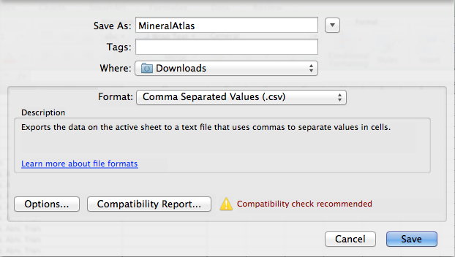

Figure 1: Save as menu

- Then you can import this information into the page to replace the table you deleted before. Go to File>Import>Import Tabular Data. A window will pop up that gives you the option to either select a source or to browse. Click whichever of these options pops up and select the .csv file and then hit enter to finish importing. It may show an option at some point to make the top row different. If given this option, Bold the top row. Once the new table appears, select the column with all of the minerals in it and in the properties window, select Bold to bold the mineral names. Additionally, change any other font or text size issues to make the table visually appealing and easily readable. Once the information has been updated, the .csv file can be deleted. DO NOT delete the actual spreadsheet that is an .xlsx document, just the temporary .csv file you created.

- Save the .htm file and make sure that it replaces the original in the folder where the website files are stored, otherwise the website will not draw from the new file and will continue to read the old one.

*For questions or problems with other updates to the website, YouTube videos on using Dreamweaver are particularly useful as well as forums online where people have posted questions.

