Water Quality of Heath Creek

Robyn Hendrix
Kelly Lewis
Brody Sandel
Leah Sipher-Mann

Carleton College
Geology Department
2003

Introduction

Agriculture can have a substantial impact on aquatic systems, including input of nutrients, geological formations and alterations of characteristics such as pH and dissolved oxygen capacity (Legg et al. 1997). These, in turn, have important consequences for aquatic life, with effects that can persist for some time. Studies of water quality are imperative in order to understand the impact human activities are having on our water. Nitrate and phosphate are of particular concern, as they are typically responsible for any eutrophication of waters (Wetzel 2001).
Several factors may influence levels of ions in the water. As we have mentioned, degree and type of fertilization is significant (Legg et al. 1997). However, timing and amount of rainfall may also be quite important, as could the geological context of the stream. High levels of rain may have affected the input of nutrients and the pH level (Likins et al. 1996). The limestone that constitutes the bedrock for much of the Heath Creek watershed may contribute to increased pH as well (USGS information).
Our research will be of particular interest to local farmers. Because agricultural land produces nitrate, phosphate, and other nutrient inputs, it is essential that farmers remain aware of how they are affecting the natural habitat surrounding the creek. If it is found that Heath Creek contains potentially harmful levels of nutrients, then increased monitoring and regulation of fertilizer use by Rice County might be required. The elements present as well as those absent from the collected data may help determine causes for rapid, regular or deteriorating growth of the terrestrial environment and downstream aquatic systems.
The present study is intended to inform farmers, recreational users and the city of Northfield about their impacts on their water, and the consequences those impacts might have on them. We used guidelines set by the Environmental Protection Agency (EPA), in order to determine whether the water of Heath Creek in Rice County, Minnesota is of satisfactory quality. Specifically, we tested for seven anions: phosphate, sulfate, bromide, chloride, fluoride, nitrate and nitrite over a 6-week period in the Spring of 2003. We also measured several characteristics of Heath Creek, including pH, dissolved oxygen content, conductivity, and water clarity.

Methods
Heath Creek runs from Union Lake to the Cannon River (figure 1) and passes through a diverse selection of land, including grassland and deciduous forest. The creek is bordered by a narrow riparian corridor, but the majority of the watershed is agricultural land. Geologically, Heath Creek has a gradient of <1%, and primarily flows over two soil types: Houghton and Muskego soils and Rush river fine sandy loam (GIS data on Rice County soils).
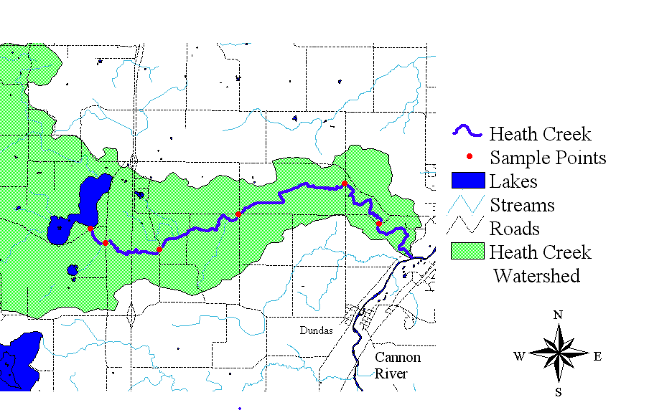
Figure 1: The Heath Creek watershed, including all sample points used in this study. Heath Creek originates in Union Lake and empties into the Cannon River.
Focusing on six points along the creek (figure 1), we took samples from sites at which Heath Creek crossed paved roads, farmland, and rural residential neighborhoods. We started by taking samples from Heath Creek’s source, Union Lake. We then followed the creek and took samples where it crossed Highway 46 (.8 kilometers from the lake), Albers Avenue (4 km), Baldwin and 90th (6.1 km), Decker Avenue (10.2 km), and Old Dutch (11.8 km). We took samples from the first five sites on April 22 while collecting data from all six sites on April 15, May 6, and May 13.
Using a Yellow Springs Inc. Model 85 meter, we measured conductivity, dissolved oxygen, water temperature and salinity. On several days, we used a pH meter in order to measure pH change within the sampling period. In order to measure water clarity, or turbidity, we used a Secchi disk filled to 120 centimeters. Slowly draining the water, we measured the depth at which the image on the bottom of the disk was visible. We also collected water samples from each site. Because we lacked an efficient way to measure depth, we relied on estimates based on the perceived depth of the creek on previous sampling dates and the amount of rainfall the area received between sampling dates. We also used physical markers of depth, such as rocks and plants, to aid us in estimating how much the water level had risen.
Once we brought each water sample back to the lab, we ran them through an ion chromatograph. The chromatograph allowed us to measure seven anions: Chloride, bromide, fluoride, nitrite, nitrate, phosphate, and sulfate. We then analyzed the anion results in order to reach conclusions about the current state of Heath Creek.

Results

Of the seven anions investigated in this study, six were found in water samples from Heath Creek: nitrate, nitrite, chloride, fluoride, phosphate and sulfate. Bromide was not found in any measurable quantities. Chloride and sulfate were the most abundant anions, with concentrations generally between 20 and 30 ppm. Nitrate-N levels were always less than 2 ppm and nitrite-N; phosphate and fluoride were either absent or below 1 ppm.

Figure 2: Increasing nitrate levels along Heath Creek. Generally, nitrate levels increase further from the lake and increased through the sampling period (from April 15th to May 13th). Runoff from surrounding agricultural land likely contributed to increasing nitrate levels. In addition, low biological demand in the creek relative to the lake probably allowed nitrate to accumulate.

There were interesting trends in nitrate levels. With only one anomalous data point, nitrate levels increased steadily with distance from the lake, as well as with time (figure 2). Sulfate levels stayed remarkably constant at 22-23 ppm through the sample period, until May 13, when levels dropped to below 20. Interestingly, phosphate was absent from all samples until the final date, when it appeared at very low levels. Fluoride, chloride and nitrite did not seem to display any trends in levels.
Physical measurements of the stream indicated a rough correlation between water levels and rainfall events, and there were several substantial storms in the study period (figure 3). Although conductivity data was highly variable, there appeared to be a trend towards higher conductivity values at increasing distances from the lake (figure 5). The pH readings ranged greatly, from 6.65 to 9.5, with no clear trend in time or location.
Our data is comparable to the limited historical data available. Nitrate, chloride, nitrite and fluoride levels were similar to studies conducted in August of 2001 and October and November of 2002 (Berger et al. 2000; unpublished data by Carleton College). Sulfate levels, however, were much lower in other studies, around 10 ppm (figure 4), and phosphate was marginally higher.

Figure 3: Rainfall levels and the average depth of Heath Creek throughout the sample period. In general, creek depth can be seen to increase with rainfall events.

Figure 4: Sulfate levels remain fairly constant through time, with only a slight decrease in sulfate levels near the end of the sample period. Little change in sulfate levels along the length of the creek.

Figure 5: General increase in conductivity as distance from lake increases. Conductivity values were average across all sample dates. Although variability was quite high, the trend is still fairly clear. As the creek dissolves its substrate and takes in runoff from the surrounding land, ions accumulate, leading to the increased conductivity. Error bars represent +/- 1 standard error.

Discussion
When comparing the chemical content of Heath Creek to EPA standards for drinking water, we found that water in Heath Creek generally falls within these safety limits (EPA guidelines). The measurements of ions were always below the standard, though the pH was slightly high. This may be due to the erosion of calcium carbonate from the underlying bedrock in Union Lake, causing the water to become more basic.
Although ion concentrations are within acceptable limits right now, there is still room for improvement and there may be cause for concern in the future. The steady increase of nitrate through time and distance from the lake is caused by several factors. First, in the lake there is a high volume of water and thus a lower concentration of nitrate, but when the water flows into the creek the volume decreases, so that nitrate can easily reach a higher concentration. The biological demand which consumes nitrate and other nutrients is higher in the lake than in the creek. Finally, the nitrate level increases as the water flows past many acres of agricultural land, so runoff from fertilizers is a primary source of additional nutrients. This may not add up to an unhealthy amount in Heath Creek, but when the creek joins the Cannon River these nitrates will be adding to pollution downstream. The runoff into the numerous creeks that flow into the Cannon may accumulate and eventually reach unacceptable levels downstream.
Sulfate levels were constant regardless of time or place, so there does not seem to be any additional source of sulfate coming from the surrounding agricultural land. This is consistent with the fact that the major source of sulfate input into streams is often weathering of pyrite in the stream bed rock (Rudd et al. 1986). Chloride levels were relatively uniform across all sample points. However, we cannot rule out the possibility that road salting provides a significant chloride input, as all of our sample points were very close to roads. The nitrite levels were so low that it is difficult to conclude anything, though they did increase slightly through time.
Since Heath Creek seems relatively safe and unpolluted compared to other streams, it is evident that some measures have already been taken to reduce risk from fertilizers. The creek is nearly always surrounded by a thin strip of forest land on each side of the bank. This is important in filtering the water running off into the stream and creating a barrier between the water and the farmland. We suggest that use of fertilizer on agricultural land is limited as much as possible in order to reduce the levels of nitrate and other nutrients in the water. A reduction of the use of tiles, which prevent water from being filtered through the soil by carrying contaminated water to the stream more quickly, would also lower the amount of ions in the creek water.
The results found in spring 2003 are similar to those found in earlier sampling of the stream (Barger et al. 2000). Some differences in results may be due to the time of year the sample was taken, since ion content changes naturally with the seasons as well as artificially in relation to the agricultural cycle.
There are several possible sources of error in this study of Heath Creek water quality. One source of error may be that samples were only taken at locations where the creek intersected a road, and runoff from the road may have an impact on water content. Only one test was conducted at each site each day of sampling. The measurements of turbidity can often be subjective depending on the measurer’s eyesight and standards of how visible the bottom of the tube must be. One on occasion there was accidental human contact with the creek bed before sampling turbidity. This caused sediment to rise unnaturally and may have affected the turbidity reading. The water sample taken back to the lab was not always tested immediately upon arrival. Some samples sat for several hours before being tested, and there could have been some change in composition during that time. There may also be some human errors regarding the cleaning of the bottles used to collect samples, such as failure to thoroughly clean or accidental touching while collecting samples.

Acknowledgements
We are grateful to Bereket Haileab for guidance and assistance in carrying out this study, Liz Clark for assistance analyzing samples, and Melissa Keevil for providing transportation. We would also like to thank the Carleton College Geology Department for providing equipment and support for this study.

References
Barger, S., M. Chen, E. Figueroa, B. Knight. 2000. “Hydrology and Morphology of the Heath Creek Watershed” Carleton College.

EPA Water Quality Standards, http://www.epa.gov/safewater/dwinfo/mn.htm

Legg, B.J.; V.R. Phillips; T.R. Cumby; C. H. Burton; P. C. H. Miller. 1977. Farming: Closing the Cycle. Philosophical Transactions: Mathematical, Physical and Engineering Sciences. Vol 355: 1728.

Likens, G.E.; C.T. Driscoll; D.C. Buso. 1996. Long-term Effects of Acid Rain: Response and Recovery of a Forest Ecosystem. Science. 272:244-246.

Rudd, John, C.A. Kelly, A. Furutani. 1986 “The Role of Sulfate Reduction in Long Term Accumulation of Organic and Inorganic Sulfur in Lake Sediments” Limnology and Oceanography, Vol. 31: 1281-1291

Tate, C.M. 1990. Patterns and Controls of Nitrogen in Tallgrass Prairie Streams. Ecology, Vol 71: 2007-2018.

Water Quality Monitoring. 1987. Office of the Legislative Auditor, State of Minnesota.

A Study on the Water Quality of Rice Creek
Spring 2003
Environmental Geology 120

Sarah Gettie Burks, Sam Holmes, Rebecca Isaacson & Nikki Johnson
Introduction:
The Rice Creek Basin (figure 2) is a part of the larger Cannon River Watershed in southeastern Minnesota, an area where 66% of the land is cultivated, 13% forested and 17% open or pasture lands (Guzmán 2002). Previous studies have been conducted to determine whether the creek’s location in relation to land use has affected its water quality. The most significant studies include the Northfield-based Spring Brook Committee, the Cannon River Watershed Partnership, the Minnesota department of Natural Resources, the Carleton College Geology Department, the Keck Geology Consortium and Kizzy Guzmán’s 2002 Senior Integrative Exercise from Carleton College on Rice Creek (Guzmán 2002). These studies found that the area’s agricultural land-use patterns did affect the creek’s water quality. Guzmán also addressed the need to document current water quality as plans begin for increased residential and recreational use of land near the creek. If these plans are realized, it will be important to have knowledge of their impact upon the surrounding water ways.
The purpose of this study is to further contribute to the data and information presented by Guzmán in her 2002 report. Her data was obtained in the summer of 2001. By collecting samples almost two years later, we can observe the current water conditions and if they have changed significantly in the past two years. Through our data collection, we look to find if the Best Management Practices (BMPs) advocated by the previous studies have been implemented, and as a result have caused a water quality improvement, or if agriculture and land use patterns continue to negatively affect water quality. We hope to share our results not only with the Carleton Geology Department, but also with the residents of Rice County, in particular those living and working near Rice Creek.

Methods:
We collected samples on five occasions over the course of one month, April 17-May 15, 2003. There were four different sampling locations along Rice Creek in our study (figure 2): Bachrach Avenue, Cates Avenue Tile, 100th East and Decker Avenue, and Dundas Boulevard RR Crossing. At each site, we collected water samples to test for the presence of nutrients in the laboratory, using an ion chromatograph. (The seven anions tested for were Fluoride, Chloride, Nitrite, Nitrate, Sulfate, Bromide, and Phosphate). We also conducted onsite monitoring using a Yellow Springs Instruments, Incorporated, Model 85 (YSI meter), pH meter, Secci meter, and a depth stick. Through these measurements, we looked to evaluate the present conditions of Rice Creek, and understand the impact of land use and the surrounding topography on its water quality.
The readings from the YSI meter provided us with information on several aspects of the creek’s chemical and physical properties, such as conductivity, dissolved oxygen content, salinity, and temperature. Conductivity (μs) measures the “ability of an aqueous solution to carry an electrical current” (American Public Health Association 1981), and is thus an important indicator of the amount of nutrients dissolved in the water. Dissolved oxygen content (mg/L) is essential in assessing water quality, as aquatic life is dependent on the oxygen transported in the water (Hunt 1996). Levels above 5 mg/L are optimal (Bereket Haileab, personal communication). Salinity (ppt) measures the “total solids in water after all carbonates have been converted to oxides, all bromide and iodide have been replaced by chloride, and all organic matter has been oxidized” (APHA 1981). Temperature (°C) is an important measurement in that it influences the dissolved oxygen (DO) content, with the DO content lowering in warmer water. pH is reflective of the carbonate, bicarbonate, and hydroxide content of the water (APHA 1981).
To evaluate the clarity or visibility of the water, we filled a Secci meter with water, recording the depth in centimeters at which a black and white disk was visible. These measurements correlate with the environmental factors. For example, rainfall increases the amount of sediment present in the water, decreasing visibility. Finally, the depth of the creek was recorded using a depth stick. This source of information is fairly unreliable, however, as heavy rainfall and slight flooding often dictated the location from which we were able to measure.
Surrounding Elements:
When taking our water samples, we observed the conditions and current state of the land area surrounding the sampling sites. The conditions of the land in close proximity to the creek can affect the conditions of the surface and ground water and must therefore be noted. All four of our sites were located near land under cultivation, and therefore vulnerable to pollutants from that land use (Sholes 1972). One of the main types of pollution in this situation is agricultural runoff. Agricultural runoff is excess water from rainfall and other precipitation that runs off the land into the ground water. Because Rice Creek is surrounded by a lot of agricultural land, run-off must be considered in this study (Tester 1995). When uncontrolled, agricultural runoff removes topsoil, nutrients from fertilizers, pesticides, and organic materials, carrying them to the water where they become pollutants. Nutrients and pesticides present in agricultural runoff can cause serious problems, such as eutrophication and excessive algal growth. Pesticides also affect aquatic life, as they are often toxic to organisms in the water.
In conjunction with this process is erosion, where soil particles become detached from clods and the soil surface. Considering that Rice Creek is a channelized stream, it is therefore susceptible to high amounts of erosion, as it does not possess a strong riparian buffer. Erosion is the most prominent during rainstorms, which can detach or loosen up to 100 tons of soil per acre in a severe storm. The detached soil can be transported by agricultural runoff, which dislodges additional soil particles as it flows across unprotected soil surfaces. Upon reaching the waterway, this eroded soil can cover and destroy young plants, causing future drainage problems. Erosion also creates more drainage channels, making it easier for run-off to pick up sediments (Haslam 1990).
Sediments, a naturally occurring presence in the stream environment, can act as a pollutant when filling a stream, and therefore reduces the stream’s water-carrying capacity and also impairing the water quality. When runoff enters a watercourse, the lighter soil particles may remain in suspension and block sunlight vital to the growth of desirable, oxygen-producing plants living in the water. Sediment-darkened water also absorbs more heat from sunlight than clearer water, thus causing warming. The combination of warm and muddy water leads to the replacement of desirable fish species with less desirable types more tolerant to these conditions.
Another element noted in the creek’s environmental surroundings was the presence of livestock. Although we did not observe any livestock in direct contact with the creek, we noted their presence within the creek’s vicinity. Livestock produce manure, which contains high levels of nitrogen and phosphorous. The animals were not close enough for their manure to directly contaminate the creek, but it could reach the water through run-off. The surroundings of Rice Creek, then, seem to indicate an increased susceptability to contamination given its proximity to agricultural land and livestock.

Results:

The following paragraphs present the data retrieved from each testing occasion. We will begin, however, with some general information concerning climate on the dates of sampling. The average temperature for the first day of our sampling, April 17, 2003, was 0.67ºC and there had been heavy precipitation within the past 24 hours—1.39 inches within the past 72 hours. On our second day of sampling, April 24, 2003, the average temperature was 11.67ºC with only light precipitation five days before, presenting 0 inches of precipitation within the previous 72 hours. The third day, May 8, 2003, yielded an average temperature of 10.67ºC. It had rained two out of the previous three days, yielding 0.64 inches of rain within the previous 72 hours. The average temperature for the fourth sampling day, May 11, 2003, was 7.72ºC and it had rained heavily both the day before and that morning, producing 2.15 inches of rain within the 72 hours prior to our sampling. Finally, our last day of water sampling, May 15, 2003, had an average temperature of 14.06ºC, and it had rained two days prior to our sampling, providing 0.28 inches of rain within the previous 72 hours. Table 1 presents the specific nutrient content at each site on the five sampling dates. Bromide and phosphate, two of the anions we tested for, were present only in negligible amounts.

Table 1:

________________________________________________________________________

Fluoride (mg/L)

Chloride (mg/L)

Nitrite- N (mg/L)

Nitrate-N (mg/L)

Sulfate (mg/L)
________________________________________________________________________

Temperature
The temperature of the water at the testing sites increased consistently over time, with the exceptions of May 11, a day on which it had rained heavily both that morning and the day before, May 8 when it was 0.1ºC colder at the Dundas RR Crossing site than it had been on April 24. The coldest water temperature occurred on April 17, 2003 at the Cates Avenue Tile site and was 4.2ºC; the warmest temperature occurred on May 15, 2003 at the Bachrach Avenue site and was 16.7ºC.

Conductivity
Between April 17, 2003 and May 8, 2003, conductivity levels increased at every site but at the Dundas RR Crossing site, where it was slightly lower on May 8 than it was on April 24—656μs versus 669μs. On May 11, the day with the heavy rains immediately before our testing, the conductivity levels decreased significantly, dropping from levels such as 661μs at Bachrach Avenue on May 8 to 292μs on May 11. Similar results were seen at each site. Finally, on the last day of water sampling, the conductivity levels had again increased, but they were not quite up to the levels at which they were before. For instance, on May 8, conductivity at Cates Avenue Tile was 690μs, on May 11 it was 339μs, and on May 15 it was 607μs.
pH
We took pH measurements on only two days as a result of only having the pH meter available for those two days, May 8, 2003 and May 15, 2003. On the 8th, the pH at Bachrach Avenue was 7.94, at Cates Avenue Tile 8.09, at 100 and Decker Avenue 8.07, and at Dundas RR Crossing 10.4. On the 15th, it was 7.8 at Bachrach Avenue, 7.69 at Cates Avenue Tile, 6.64 at 100 and Decker Avenue, and 10.38 at Dundas RR Crossing.
Dissolved Oxygen (mg/L)
We have not established any patterns for the dissolved oxygen content, however the levels were unusually high at the Bachrach Ave. and Cates Ave Tile sites on April 24, 2003. The results are displayed in Table 2.
Table 2:
________________________________________________________________________
________________________________________________________________________

Salinity (ppt)
For every site on every sampling date—with the exception of May 11, 2003 immediately after the heavy rains—the salinity was at 0.3 ppt. On May 11, 2003, the salinity was 0.1 ppt at the Bachrach Avenue site and 0.2 ppt for the other three sites.

Color
The water color at every site for each sampling date was clear with the exceptions of the 100 and Decker Avenue site on April 17, 2003, where it was light brown, and on May 11, 2003, when the water color was light brown for all four sites.
Discussion:
In looking over the compiled data of nutrient information, we recognize that all nutrient levels were far below EPA (Guzmán 2002) maximum contaminant levels with the exception of nitrate. It is now necessary to evaluate the causes of these results, with specific attention given to the effects of rainfall, chloride and nitrate levels, and nonpoint versus point sources of contamination.

Rainfall
The nutrient levels in Rice Creek dropped significantly following a heavy rainfall on May 10 and 11, 2003 (figures 3, 4). This drop occurred across the board, with each nutrient decreasing in concentration. The decrease in nutrients following increased precipitation was unexpected, as our research had led us to expect increased nutrient levels following rainfall; this expectation was based on the belief that increased erosion and the influx of shallow underground water would lead to a higher nutrient concentration (Haslam 1990). In an agricultural area, it is typically expected that increased erosion leads to a larger presence of nitrate due to the use of fertilizers and pesticides. This, however, was not the case with our data, as nutrient levels decreased following rainfall. In assessing this phenomenon, we hypothesized that if rainfall causes an increased discharge and stream velocity, then the nutrients were dispersed through a greater volume of water and therefore diluted, causing the nutrient concentration decrease that we observed. For the next testing date, the nutrient levels were still not up to the levels they had been at pre-rainfall; however, they were increasing and appeared to be bouncing back.

Chloride
With regards to chloride concentration, we expected there to be a decrease in the amount of chloride between our first day of sampling and the last. This assumption was based on the fact that our first testing date was still relatively close to winter, with the presence of low temperatures and snowfall. Snowfall results in the application of salt on the roads, and this salt dissolves in the runoff flowing into the creek; therefore the expectation is to observe a substantially increased chloride concentration in winter than mid-May, when snow, and the accompanying salt, is no longer present. This, however, was not an observable trend, because although there was a slight decrease in chloride levels over time, this decrease was statistically negligible, implying that the length of time between the last application of road salt and our first sampling date was greater than we had previously anticipated. In addition, the amount of chloride, in correspondence with the other nutrients, decreased with the heavy rainfall, only to begin increasing again in the following sampling date.

Nitrate-N
The observed levels of nitrate were significantly higher than those set as maximum contamination levels for drinking water by the EPA, (Guzmán 2002) as is shown in table 3.
Table 3:
________________________________________________________________________

Nutrient | Maximum Contaminant Level (mg/L) | Our Data Average Levels (mg/L)
Nitrate-N | 10 | 13.7635
Nitrite-N | 1 | 0.0769
Sulfate | 250 | 15.31234
Chloride | 250 | 16.733
Fluoride | 4 | 0.1711

________________________________________________________________________

Nitrate was the sole nutrient to surpass the EPA levels. We propose that the increased nitrate concentration is due to local agricultural fertilizer application and run-off. Agricultural run-off is the source of 52% of total nitrogen discharged into US waterways, and this remains true in this waterway in southern Minnesota (Allan 1995). The increased presence of the nitrate can have harmful effects on the creek, including eutrophication. Eutrophic water results from an excess presence of nutrients, and can cause such phenomena as algal bloom (Harper 1996). This bloom blocks sunlight from reaching the plant life below the water’s surface.

Non-point vs. Point Sources of Contamination
The attribution of non-point vs. point source is relative to the scope of the water basin under consideration (Kennish 1992). Although agriculture is considered a non-point source on a larger national level, when the larger Mississippi water basin is evaluated, the local agriculture of Rice County can be seen as a point source of contamination for Rice Creek, which is a tributary to the Cannon River, which in turn is a tributary to the Mississippi River. As a result, Rice Creek is an indirect point source of nitrate contamination to the Mississippi, and although it is not the only source or even the main contaminant, Rice Creek contaminates the River near its headwaters, leading to a higher base level of nitrate downstream. This addition of nutrients is continued through erosion and run-off in the agriculturally dominated Plains area, all the way down to the Mississippi Delta in Texas. When not looking at a specific source, however, agriculture is considered a non-point source, and as found in the Journal of Soil and Water Conservation, “Pollutants from non-point sources (NPS) significantly impair water quality in many, perhaps a majority, of water bodies in the north central United States. . .The Environmental Protection Agency (EPA) has described non-point source pollution as ‘the nation’s largest water quality problem.’ The EPA also finds that agriculture is the main culprit in this situation, and reports that 60% of impaired river area and 50% of impaired lake area surveyed in the 1994 water quality inventory were found to be degraded by agricultural sources” (Braden 2000).
Another relevant source of contamination is the non-point pollution caused by acid rain. Acid rain contributes to the sulfate levels in the water, however, in relation to the EPA maximum contamination levels, Rice Creek contained a relatively low sulfate concentration. This lower level could be attributed to the lower acidity of Midwest rain in comparison to the greater acidity of northeast rain. This difference is due to varying air currents and amounts of industrialization in the surrounding areas.
Conclusion:

As our project demonstrated, nitrate continues to contaminate Rice Creek. Although Rice Creek has acceptable levels of the other anions, nitrate can alone cause a substantial decrease in water quality. Given that studies conducted through the 1970s until the present have all come to the same conclusion of the need to reduce nitrate levels, it is time for the Rice County community to take action. This water quality review, like the previous studies, reiterates the importance of the implementation of BMPs in assuring the maintenance and improvement of creek health. A shift in agricultural practices could alter the trend of high nitrate levels. Farmers could decrease the application levels of nitrogen rich fertilizers and implement a split application technique of fertilizer application, where fertilizer is applied in stages throughout the year rather than all at once (Braden 2000). In addition, the state of Minnesota could offer an incentive program for farmers to improve their agricultural practices and the water quality of any waterways near their land under cultivation (Braden 2000). Research on fertilizer application and the amount required for different crops and soils and its effects on water quality should also continue. An improvement of Rice Creek’s water quality is dependant on environmentally aware land-use patterns.
Exploring Margin of Error & Recommendations for Further Study:
In testing the water quality of Rice Creek, we found there were many variables affecting the data collection process. When future studies are undertaken, the following variables should be taken into account: The geology and topography of the site must be assessed, including the surrounding soil and bedrock types, as their erosion comes to effect water quality. In addition, the specific forms of land-use surrounding the stream, such as agriculture or livestock, should be investigated. The number of animals and their proximity to the creek is an important variable, as they cause defoliation of riparian vegetation and contribute to the nitrogen level in the water through their feces and urine. Even more important is the evaluation of the land-use pattern, indicative of the manner in which farmers utilize the land. An investigation of farmers’ specific form of cultivation – the types of crops grown, the number of harvests, the types of fertilizers and pesticides utilized and their chemical composition, and how frequently these chemicals are applied – is essential in evaluating the health of a local body of water.
Another consideration must be the time of year testing is conducted. Guzmán tested in the summer, while we gathered our samples in the spring. The differing seasons are important for several reasons, as rainfall does not only vary by season, but also farmers’ tilling practices and fertilizer and pesticide application are seasonally dependent. In addition, as was mentioned earlier, chloride levels are higher in the early spring as a result of the salt application to local roads during the winter months. The varying temperatures also influence results, as dissolved oxygen content directly correlates with temperature. Another important factor affecting the outcome of data is the precision of measurement. The accuracy of actual onsite testing may be influenced by human negligence, or as we experienced, an inability to collect samples and measure stream depth at exactly the same location on each testing occasion. We experienced this problem after severe rainfall when the resulting rise in water level prevented us from standing on the same bank from which we had previously tested.
Future studies should also include many test points along the creek, so as to take into account the topography variance and the differences resulting from the way in which the stream has been channelized in various locations. By including a larger number of test sites and continuing tests throughout the entire year, the locational and seasonal variability would be reduced, enabling another study to obtain a better an overall view of Rice Creek’s water quality.
Acknowledgements:
We would like to sincerely thank a few people who were vital in helping us both understand and complete this project. First and foremost, Bereket Haileab, our geology professor and resident water chemistry expert, who answered many questions and ponderings in the van and over cups of coffee. In addition, Liz Clark was extremely patient in explaining the intricacies of the ArcView program, and Ben Harrison and Joseph Graly provided valuable technological and scientific assistance.

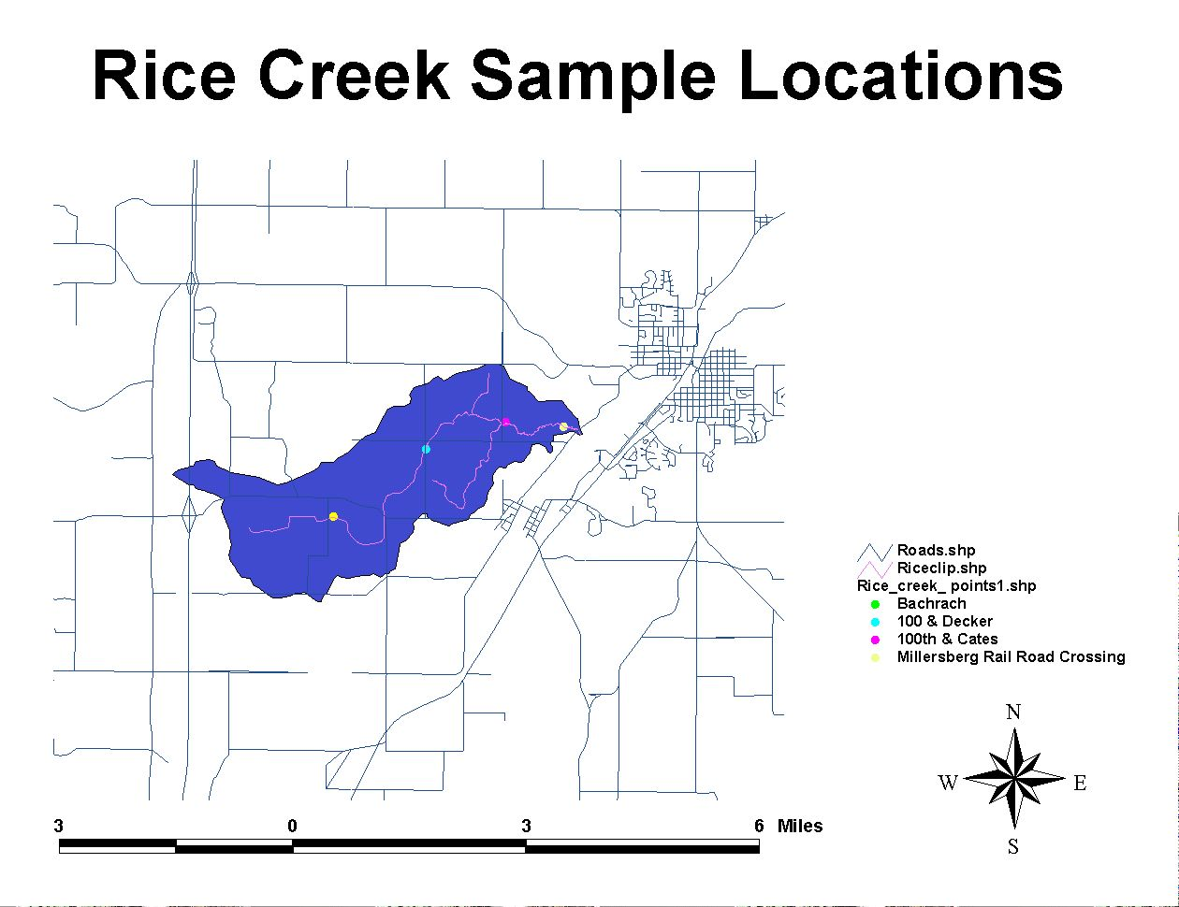
Figure 2

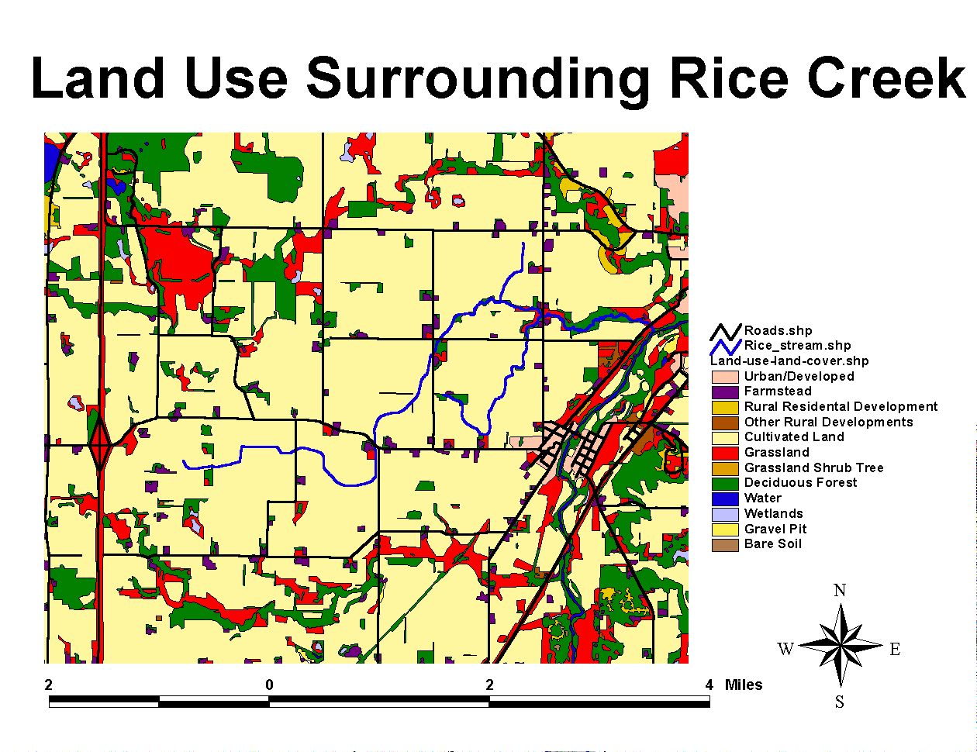
SHAPE \* MERGEFORMAT

Figure 5
Bibliography

ALLAN, J. David. Stream Ecology: Structure and function of running waters. London: Chapman & Hall, 1995.

AMERICAN PUBLIC HEALTH ASSOCIATION, American Water Works Association, Water Pollution Control Federation. 1981, Standard Methods: for the examination of water and waste water. Washington D.C.: American Public Health Association.

BRADEN, J.B., and E.A. DeVuyst, R.H. Hornbaker, B. Shankar, D.C. White. 2000. Nitrate Abatement Practices, Farm Profits, and Lake Water Quality: A Central Illinois Case Study, The Journal of Soil and Water Conservation, v55 i3 p296.

GUZMAN, Kizzy 2002. Effects of Local Land Use On the Water Quality and Physical Habitat of the Rice Creek Watershed, Minnesota, USA. Senior Integrative Exercise.

HARPER, David M., and Alastair J.D. Ferguson, eds. The Ecological Basis for River Management. New York: John Wiley and Sons, 1996.

HASLAM, S.M. River Pollution: An Ecological Perspective. New York: BelhavenPress, 1990.

HUNT, DTE, and A.L. Wilson. The Chemical Analysis of Water: General Principles and Techniques. London: The Royal Society of Chemistry, 1996.

KENNISH, Michael J. Ecology of Estuaries: Anthropogenic Effects. Boca Raton: CRC Press, 1992.

SHOLES, Owen 1972. Land Use Suitability Survey National Science Foundation in Student-Oriented Studies. Northfield, MN: Carleton College.

TESTER, John R. Minnesota’s Natural Heritage: An Ecological Perspective. Minneapolis & London: University of Minneapolis Press, 1995.

A Study of the Chemical and Physical Properties of Wolf Creek at Five Different Locations, Spring 2003
By

Amanda Dowell
Dan Pulver
Kayeen Thomas
Samantha Greenwald

Introduction

Wolf Creek is part of the Cannon River Watershed in the southeastern part of Minnesota. The Cannon River is the main body of water in this watershed, and it is a tributary of the Mississippi River. Wolf Creek is a major tributary of the Cannon River, and the former flows into the later just south of Dundas, Minnesota. The Wolf Creek Drainage basin is located between the towns of Northfield and Faribault (Fig. 1). 91.3% of the land surrounding Wolf Creek is occupied by livestock or crops. The majority of farmland that abuts Wolf Creek contains a wooded riparian zone that is anywhere from 0.5 meters to 50 meters wide (Charles-Guzman, Cooper, Hodo, Kaba, and Kim, 2001).
This study focuses on five specific sites on Wolf Creek in Rice County, Minnesota (Fig. 1). The first site, (location 1), was right along Highway 3. The second site, (location 2), was at the intersection of Cabot and 120th Street. The third site, (location 3), was at the intersection of Road 76 and 120th Street. The fourth site, (location 4), was at the intersection of Road 60 and 120th Street. And the fifth and final site, (location 5), was at the intersection of Road 9 and Road 36.
The purpose of this project was to study the chemical and physical properties of Wolf Creek in order to draw conclusions about the status of this stream’s health. It is our goal that this analysis will serve future Carleton students, faculty, and residents of Rice County, as they continue the process of monitoring and studying our community’s surface water.
Throughout our study of Wolf Creek we measured pH, temperature, dissolved oxygen, conductivity, salinity, turbidity, chloride, nitrate, and sulfate.
Procedure
All data was collected over four trips to five specific parts of the stream. On the first trip to the field a pH meter was used to measure the pH of Wolf Creek. A Yellow Springs Instrument Inc. Model 85 was used to measure temperature, dissolved oxygen, conductivity, and salinity. And a 130 cm long Secchi Disk was used to measure the turbidity of Wolf Creek.
Water samples were also taken at each location. These samples were analyzed for seven anions using a Dionex 600 Ion Chromatograph. It is important to note that only three of these seven anions, (chloride, nitrate, and sulfate), were significant enough components of Wolf Creek to show up on the chromatograph.
Observations and Results
Fig #2: We sampled the pH of Wolf Creek at five different locations on the first day of sampling, April 17, 2003. The pH ranged from 7.0-8.0 with an average of 7.6.
Fig #3: We Sampled the temperature of Wolf Creek at five different locations on four different sampling days. At each sampling location the temperature rose over time. Over the course of one month the temperature increased by 8.3 degrees centigrade at location 1, 8.6 degrees centigrade at location 2, 8.1 degrees centigrade at location 3, 6.0 degrees centigrade at location 4, and 10.7 degrees centigrade at location 5. Between all five locations there was an average rise in temperature of 8.3 degrees centigrade.
Temperature of Wolf Creek at Different Locations Over Time (centigrade)
 |  | 17-Apr | 24-Apr | 08-May | 15-May
 | location 1 | 6.9 | 12.3 | 14.5 | 15.2
 | location 2 | 6.6 | 11.9 | 14.1 | 15.2
 | location 3 | 8.7 | 13.2 | 16.2 | 16.8
 | location 4 | 9.5 | 13.6 | 15.5 | 15.5
 | location 5 | 7.3 | 14.2 | 15.6 | 18

Fig #4: We sampled dissolved oxygen in Wolf Creek at five different locations on four different sampling days. At each location the amount of dissolved oxygen did not decrease steadily on every successive sampling day, but overall dissolved oxygen did decrease at each location. The average amount of dissolved oxygen at location 1 was 11.59 mg/Liter, at location 2 was 11.54mg/Liter, at location 3 was 8.85 mg/Liter, at location 4 was 10.39mg/Liter, and at location 5 was 10.14mg/Liter.
Amount of Dissolved Oxygen in Wolf Creek at Different Locations Over Time (mg/Liter)
 |  | 17-Apr | 24-Apr | 08-May | 15-May
 | location 1 | 12.7 | 13.3 | 11.44 | 8.9
 | location 2 | 13.85 | 13.54 | 10.12 | 8.66
 | location 3 | 10.91 | 13.4 | 2.76 | 8.34
 | location 4 | 9.41 | 15.84 | 6.9 | 9.4
 | location 5 | 12.17 | 11.12 | 8.94 | 8.34

Fig #5: We sampled the conductivity of Wolf Creek at five different locations on four different sampling days. Each sampling location followed a similar pattern. The first sampling day yielded the highest conductivity at each site, the next sampling day there was a decrease in conductivity, then on the third sampling day there was a slight increase in conductivity, and finally on the last sampling day the conductivity of Wolf Creek dropped once again. The first sampling day, April 17, 2003 yielded the highest conductivity by a lot at each sampling site.

Conductivity of Wolf Creek at Different Locations Over Time (ms)
 | 17-Apr | 24-Apr | 08-May | 15-May
location 1 | 478 | 371.3 | 409.4 | 361.6
location 2 | 470.3 | 362.4 | 398.6 | 359.1
location 3 | 395.5 | 337.7 | 366.2 | 342.1
location 4 | 393.3 | 309.2 | 332.1 | 319.7
location 5 | 416.3 | 387 | 372.5 | 311.6

Fig #6: We sampled the turbidity of Wolf Creek at five different locations on four different sampling days. The turbidity of Wolf Creek remained fairly constant at location 1-4. At these four locations the turbidity never rose or dropped, but overall turbidity at these first four locations did increase over time. Location 5 is different. Although it started with around the same turbidity as that of the other four locations, its turbidity decreased each sampling day until by the last two sampling days the amount of water in the Secchi Disk was at a maximum.
Turbidity of Wolf Creek at Different Locations Over Time (cm)
 | 17-Apr | 24-Apr | 08-May | 15-May
location 1 | 53.9 | 28.1 | 39.4 | 27.2
location 2 | 61 | 33.9 | 46.2 | 28
location 3 | 46.8 | 31.4 | 50.6 | 28.2
location 4 | 45 | 26.2 | 30.8 | 30
location 5 | 62.2 | 89.4 | 122 | 122
Fig #7: We sampled the amounts of chloride, nitrate, and sulfate at location 1 on four different sampling days. The amount of chloride dropped by over 19mg/Liter from the first sampling day to the second, and then fluctuated at fairly steady levels. Nitrate remained at very low levels and stayed incredibly steady over all four sampling days. Sulfate fluctuated up and down in small increments over all four sampling days.
Amount of Three Chemicals in Wolf Creek Location 1 Over Time
 |  | 17-Apr | 24-Apr | 08-May | 15-May
 | chloride mg/L | 33.2345 | 13.752 | 14.9561 | 12.3452
 | nitrate mg/L | 2.4337 | 0.5707 | 0.9195 | 1.0427
 | sulfate mg/L | 26.4605 | 21.4263 | 23.3564 | 21.0277

Fig #8: We sampled the amounts of chloride, nitrate, and sulfate at location 2 on four different sampling days. The amount of chloride again dropped by over 13mg/Liter from the first sampling day to the second, and then fluctuated at fairly steady levels. Nitrate remained at very low levels and stayed incredibly steady over all four sampling days. Sulfate fluctuated up and down in small increments over all four sampling days.
Amount of Three Chemicals in Wolf Creek Location 2 Over Time
 |  | 17-Apr | 24-Apr | 08-May | 15-May
 | chloride mg/L | 27.0824 | 13.5935 | 15.1374 | 12.3605
 | nitrate mg/L | 2.3382 | 0.4666 | 0.8023 | 0.9702
 | sulfate mg/L | 26.7078 | 20.8609 | 22.9775 | 21.1717

Fig #9: We sampled the amounts of chloride, nitrate, and sulfate at location 3 on four different sampling days. Chloride, nitrate, and sulfate all fluctuated at fairly steady levels.
Amount of Three Chemicals in Wolf Creek Location 3 Over Time
 |  | 17-Apr | 24-Apr | 08-May | 15-May
 | chloride mg/L | 20.2674 | 12.8738 | 3.9891 | 11.857
 | nitrate mg/L | 1.0682 | 0.1347 | 0.2475 | 0.5598
 | sulfate mg/L | 25.8444 | 21.2667 | 23.3505 | 21.2282

Fig #10: We sampled the amounts of chloride, nitrate, and sulfate at location 4 on four different sampling days. Chloride remained incredibly steady over all four sampling days. Nitrate also remained incredibly steady and at very low amounts over all four sampling days. Sulfate dropped by over 19mg/Liter from the first to the second sampling day, and then continued to fluctuate at steady levels.
Amount of Three Chemicals in Wolf Creek Location 4 Over Time
 |  | 17-Apr | 24-Apr | 08-May | 15-May
 | chloride mg/L | 14.4149 | 11.0118 | 11.8235 | 11.1772
 | nitrate mg/L | 1.2543 | 0 | 0 | 0.3046
 | sulfate mg/L | 38.328 | 18.4764 | 19.9004 | 19.7596

Fig #11: We sampled the amounts of chloride, nitrate, and sulfate at location 5 on four different sampling days. Chloride remained incredibly steady over the first three sampling days, and then dropped slightly on the last sampling day. Nitrate remained steady and at very low amounts over all four sampling days. Sulfate dropped by over 17mg/Liter over all four sampling days.

Amount of Three Chemicals in Wolf Creek Location 5 Over Time
 |  | 17-Apr | 24-Apr | 08-May | 15-May
 | chloride mg/L | 13.5152 | 13.453 | 13.4277 | 10.1661
 | nitrate mg/L | 20.3091 | 6.9806 | 4.9168 | 5.4042
 | sulfate mg/L | 31.9225 | 25.7341 | 20.8807 | 14.2852

Discussion
The water quality standards set by Minnesota Pollution Control Association deem pH levels between 6 and 8.5 healthy (Charles-Guzman, et al, 2001). The pH level is an indicator of the solubility and biological accessibility of chemical elements and heavy metals (Washington State Department of Ecology).
A waters’ pH is affected by geological formations that the water comes in contact with, and seasonal and daily fluctuations on photosynthesis. Photosynthesis causes the pH to increase, and therefore respiration causes the pH to decrease. Pollution usually creates an increase in photosynthesis, and therefore a rise in pH (Washington State Department of Ecology).
The pH values obtained at Wolf Creek ranged from 7.0 to 8.0, with an average of 7.6. These values are well within water quality standards, and therefore attest to the health of Wolf Creek.
The temperature of the water was taken during each visit to the five different locations of Wolf Creek. Although there was fluctuation in temperature between the five points, in general the temperature of Wolf Creek increased during the sampling period.
This result was not entirely unexpected. Taking into the account that the temperatures were taken between the dates of April 17 and March 15, it could easily be assumed that the water temperature would rise because of the seasonal increase in temperature. Spring and summer tend to bring warmer climates, and consequently, warmer water temperatures.
Water temperature plays a major role in the overall health of the creek. The obvious cause for fluctuations in water temperature is fluctuations in seasonal temperatures. However, other causes include water depth, groundwater inflow, and the amount of direct sunlight and shade that the water is receiving.
Water temperature has many influences on the occurrences in the creek. It can limit migration, spawning, egg incubation, growth, and metabolism of underwater organisms (“Natural Resources Facts”). The major influence that the temperature has on the creek, though, is the regulation of dissolved oxygen within the water. Warmer water holds less oxygen than colder water does, and the organisms within the creek rely on dissolved oxygen for their survival. Aquatic organisms have their own system of respiration where they consume oxygen and expel carbon dioxide while absorbing essential food molecules (“Natural Resources Facts”). Therefore, the amount of dissolved oxygen that the water holds determines how much life it can support.
The amount of dissolved-oxygen in a stream is perhaps the best indication of the stream’s health and overall water quality. Physical, chemical, and biochemical processes such as temperature, photosynthesis, respiration, amount of organic matter, surface-air contact, and human activity, all influence the amount of dissolved oxygen in a stream (Balance and Bartram, 1996) and (“Understanding Dissolved Oxygen in Streams”).
Oxygen dissolves more readily in water as temperature decreases, and thus cooler water can carry more dissolved oxygen. Dissolved-oxygen enters streams when the surface of the water comes in contact with the air. Therefore, when water flows more rapidly and the overall water flow is turbulent, more oxygen is incorporated into the stream.
Dissolved-oxygen supports aquatic life, which depends on the oxygen for respiration. The uptake of dissolved-oxygen by aquatic life is only effective above certain concentrations. Without enough oxygen, aquatic life cannot grow and reproduce successfully and sometimes the lack of oxygen can be serious enough to cause death. Dissolved oxygen is also needed for the breakdown of organic matter (Washington State Department of Ecology).
Dissolved-oxygen levels below 5 mg/Liter are harmful to most species (“Understanding Dissolved Oxygen in Streams”). Only one of our measurements at Wolf Creek went bellow 5mg/Liter, this measurement was 2.76 mg/Liter. Perhaps this was due to human error, for all of our other measurements were well above 5mg/Liter. All of our readings were also very consistent over time and location, and our values indicate that Wolf Creek is quite healthy. One trend that we observed, (except for a few dramatic shifts), was a steady decrease in the amount of dissolved oxygen. This is possibly due to an increase in aquatic life and plants as winter turned to spring, for these organisms use a good deal of the dissolved-oxygen in the water.
Conductivity, generally measured in siemens or micromhos per centimeter, is the measure of how easily an electrical current can pass through a certain material such as water. In streams, fluctuations in these measurements are directly related to the amount of dissolved inorganic anions existent in the water. Significant amounts of dissolved electrolyte anions such as chloride, nitrate, sulfate, and phosphate increase conductivity. Temperature and geophysical surroundings also contribute to water conductivity. Warmer temperatures generate higher conductivity. Also, rivers and streams that flow over clay-rich soils are generally more conductive than streams flowing over granite bedrock. While clay sheds negatively charged ions that release into the stream, granite bedrock is composed of inert chemicals that do not contribute to the water’s conductivity. According to the Environmental Protection Agency’s website on assessing water quality and specifically, conductivity, the average conductivity measurement for US streams and rivers ranges from 50 to 1500 micromhos. Pollutants such as septic runoff, road salts, and industrial discharge containing great amounts of chloride, nitrate, sulfate, and phosphate enhance a stream’s conductivity.
The five conductivity measurements that we took at Wolf Creek revealed fairly average conductivity rates, ranging from 309.2 to 478.0 micromhos. The conductivity values are very similar to those observed by a group of scientists studying Wolf Creek two years earlier. These scientists obtained conductivity values that ranged from 300-400 micromhos (Charles-Guzman, et al, 2001).
All but one site followed similar fluctuation patterns in the amounts of conductivity. As we expected from its proximity to the highway, our first measuring site had the highest conductivity rate. We hypothesize that the high conductivity is primarily due to the road salt runoff and perhaps sewage runoff. Similar variations in conductivity readings for sites 1,2,3,and 4 were probably a result of changing precipitation rates. Our highest readings for all of the sites were on day one, which followed a heavy rainstorm. Runoff from the roads and from the surrounding soil likely contributed to this high reading. The dry spell that followed this week’s measurements had the reverse affect on the water chemistry. Location 5 stands out from the rest because it does not follow the same fluctuation pattern as the others but rather a steady decline from about 420 micromhos in conductivity. It is likely that this particular site on Wolf Creek does not receive as much run-off as the other sites, particularly run-off from agricultural by-products and fertilizers.
Turbidity is defined as the cloudiness of water resulting from suspended material in the water. This suspended material decreases the ability of light to pass through the water. Reduced light penetration can limit plant growth, severely affecting the fish and invertebrate communities that feed on and live in the plants. Silt, microorganisms, plant material and chemicals can cause turbidity. However, the most frequent causes of turbidity in rivers and other bodies of water are algae and inorganic material from soil weathering and erosion. Turbidity increases after a rainfall, when excess water from the surrounding soil runs off into the river, carrying silt particles and plant material with it.
The turbidity in Wolf Creek at the first four locations was relatively consistent, with minor fluctuations depending on how recently it had rained. Location 5, however, started as turbid as the others but quickly cleared until it passed our instrument’s ability to measure. Since it was subjected to the same rainfall as the others, another reason for its clarity must be found. This is the same location that had a much lower conductivity than other locations. Therefore, again we can make the same hypothesis. It is likely that location 5 does not receive as much run-off as the other sites and thus does not accumulate as many particles and anions that encourage the growth of algae and other plants (“Physical and Chemical Tests”).
Chloride is commonly found in natural streams at certain levels. The amount of chloride found in unpolluted streams is most commonly below 10 mg/Liter, and sometimes even below 1 mg/Liter (World Health Organization). Sometimes the amount of chloride found in a stream is greater than these expected levels, and this phenomenon may be explained in a number of different ways. A large amount of chloride detected in a stream can be an indication that there are chloride-containing geological formations that are coming in contact with the water. Water is the universal solvent, and thus quite capable of dissolving chloride out of rocks and minerals. High amounts of chloride in a stream may also result from pollution by sewage or industrial wastes. If a stream is close to a road, chloride from salt and de-icing materials used in the winter months may find its way into the water. And finally, another possible source of chloride in a natural stream is from contact with seawater or saline water (Balance and Bartram, 1996).
Chloride makes water a better conductor of electricity, which in turn causes water to be more corrosive. Indeed, high amounts of chloride in water eat away at metal pipes when the chloride reacts with metal ions to form soluble salts. This chemical reaction puts more metal into the water and can be a big contaminant of our drinking water. There are not, however, any guidelines governing the amount of chloride in drinking water. There are no guidelines as of the present because chloride toxicity has not occurred in humans. Most people can take in a large quantity of chloride as long as there is a sufficient amount of freshwater entering their system as well (World Health Organization).
The amount of chloride that we found in Wolf Creek always exceeded 10 mg/Liter, however, not by a significant amount. From four different samples, the average amount of chloride that we found at location 1 was 18.57 mg/Liter, the average of location 2 was 17.04 mg/Liter, the average of location 3 was 14.75 mg/Liter, the average of location 4 was 12.12 mg/Liter, and the average of location 5 was 12.64 mg/Liter. Our readings were very consistent, and relatively low, therefore there is little need to be concerned about chloride pollution in this stream.
There are a few conclusions we can make about where this chloride is coming from. At each location the highest measurements of chloride that we obtained occurred on our first testing day, April 17, 2003. This makes sense when one considers a major source of chloride in natural waters, salt and de-icing materials. Most likely a good deal of this chloride was due to snow-melt runoff carrying salt and other de-icing materials put on the roads in the winter. Indeed, the highest amount of chloride out of all of our measurements combined occurred at location 1 on our first testing day. Location one is right on highway 3, the biggest road that Wolf Creek runs along. This highway, in comparison with all the other much smaller roads our test sites were near, gets the greatest amount of salt poured on it, and therefore this is why we got our highest chloride reading at this site on this day. It is also fair to assume that Wolf Creek comes in contact with chloride-containing rocks, for even on our last testing day, May 15, 2003, chloride levels exceeded 10 mg/Liter, although not by very much. It is also important to note that no significant amount of chloride was contributed to Wolf Creek by rainwater, because the rainwater sample that was taken during our testing period contained negligible amounts of chloride.
Nitrate is a form of nitrogen that is particularly abundant and in streams in agricultural areas. Though it is a naturally occurring chemical that plants thrive on, nitrate has become a topic of growing concern since the 1940s when the use of nitrate-rich fertilizers revolutionized farming methods (H. John Heinz III Center). These fertilizers cause nitrate to accumulate in ground and surface waters and eventually to seep into rivers and streams during wet seasons. This seasonal runoff pattern accounts for very high nitrate concentrations in streams during the winter and lower Nitrate concentrations during the summer. Nitrogen concentrations are considered high when levels reach beyond 30 mg/l. Areas where Nitrate concentrations exceed 50 mg/l, typically in inland farming zones, are considered harmful to health and often designated “nitrate vulnerable zones”. In these areas, “action programs” are often employed to reduce fertilizer use. While modern agricultural chemicals are the main source of nitrate contamination in water, human intervention such as land clearing, and sewage waste also contribute to high amounts of nitrate (H. John Heinz III Center).
In nearly all of our testing locations, the nitrate levels followed a similar fluctuation pattern. For all four sites, the first testing day yielded the highest nitrate concentrations, with the peak concentration occurring at the first site, followed closely by the third. The second testing day yielded the lowest nitrate count for all but one location (this location did not even contain nitrate on this day), followed by a fairly steady increase on the third and fourth testing days. The higher amount of nitrate in site one and three can be attributed to their proximity to the road, and therefore to chemical runoff. Also, the third site was relatively clear of nitrate-consuming vegetation. Also our first sampling day followed a strong rainstorm, which undoubtedly released a considerable amount of nitrate from fertilizers into the water.
The average amount of nitrate found at location 1 was 1.34 mg/Liter, at location 2 was 1.44mg/Liter, at location 3 was .50mg/Liter, at location 4 was .39mg/Liter, and at location 5 was 9.40mg/Liter. The average amount of nitrates obtained by the scientists studying Wolf Creek two years earlier was 7.4 mg/Liter (Charles-Guzman et al, 2001). These scientists were very concerned by these results because the water quality standards set by the Minnesota Pollution Control Agency set the level of acceptable nitrate at 5.0mg/Liter (Charles-Guzman, et al, 2001). Perhaps our nitrate values were so much lower because there have been efforts made by farmers and other citizens of Rice County to better protect their surface water, and the amount of fertilizer and other chemical run-off has been consciously reduced. Another reason for the difference might be due to the fact that the portion of Wolf Creek being studied by these scientists is downstream from the portion we studied, and thus has had more time to accumulate nitrate.
Sulfate is a common component of surface water, and it enters surface water in a variety of ways. Sulfate is released into streams as a result of the chemical decomposition of sulfur-containing organic compounds, industrial waste, fossil-fuel combustion, mining, acid rain, actual sulfate particles suspended in the air, and of course from sulfate-containing geological formations that the stream comes in contact with, such as pyrite. Sulfate is relatively non-toxic, and the World Health Organization does not set limits on the amount of sulfate allowed in drinking water (Balance and Bartram, 1996). In streams, however, high amounts of sulfate help to lower the pH. Because large quantities of sulfate tend to enter a stream at once, (usually due to seasonal fluctuations), this rapid influx causes “episodic acidification” or “acid shock.” This can harm and sometimes even kill aquatic life (National Parks and Association).
The amounts of sulfate we measured in Wolf Creek were incredibly consistent over time and between the five different locations of our sampling sites. although these values are somewhat high, the average pH of Wolf Creek is 7.6. Because this is a very neutral, and even somewhat basic pH, the amount of sulfate in Wolf Creek is not making it acidic, and at this time it is in no danger of episodic acidification, or acid shock. The sulfate in Wolf Creek is most likely coming from weathered pyrite in the limestone that the stream comes in contact with (Bereket Haileab, Personal Communication). It is definitely not coming from acidic rainfall, because there were negligible amounts of sulfate in the rainfall sampled during this study.
Conclusion
In conclusion we found Wolf Creek to be a fairly healthy stream. Almost none of the factors we measured for produced alarming results, on the contrary, the majority of the values we obtained fell at or below suggested levels for healthy streams.
The pH measurements we took of Wolf Creek all fall within the water quality standards set by the Minnesota Pollution Control Association. Our average pH is also less that of the scientists studying Wolf Creek two years ago, who were somewhat concerned with their findings. Therefore it can be concluded that Wolf Creek is in fact healthier than it was two years ago.
The conclusion drawn from the information we collected on temperature is that due to the increase in temperature in Wolf Creek, the aquatic life may be suffering. During the time we sampled, the temperature steadily increased. One might assume, then, that the temperature of the creek will continue to increase steadily up until the next seasonal change. This means that the creek will be able to hold less and less dissolved oxygen, and eventually support less and less aquatic life.
Dissolved oxygen is a good indicator of water quality. The general consensus about levels of dissolved oxygen in surface water is that amounts under 5mg/Liter are detrimental to aquatic life. Only one out of twenty of our dissolved oxygen measurements fell below this level. Therefore we can conclude that Wolf Creek has a sufficient amount of oxygen dissolved in it, and can support aquatic life.
We found that Wolf Creek contained average conductivity values. The Environmental Protection Agency claims that the average conductivity of US streams and rivers falls between 50 to 1500 micromhos. Although this is a rather large range, the values we obtained for Wolf Creek fit well within these boundaries. Our values were also very similar to a group of scientists who studied Wolf Creek two years earlier, and they were not concerned with the values they obtained (Charles-Guzman, et al, 2001). We can therefore conclude that Wolf Creek is not being contaminated by an alarming amount of pollutants.
The salinity measurements that we obtained were all the same, .2ppt. This was the same value obtained by a group of scientists two years earlier (Charles-Guzman et al, 2001). This value is .1 ppt higher than the amount recommended by Minnesota Pollution Control Agency: however this is not a significant enough amount to cause concern.
Turbidity measurements followed expected patterns. On sampling days following heavy rainfall the stream was more turbid, and vice versa. Nothing abnormal or incredibly detrimental causes added turbidity in Wolf Creek.
The amount of chloride found in unpolluted streams is usually below 10mg/Liter. Our chloride measurements were all higher than 10mg/Liter, but not by much. There have never been any guidelines set governing the amount of chloride in drinking water because it is not typically hazardous to humans. Therefore, although our chloride measurements were a little higher than expected, this is not a cause of concern.
The sites on Wolf Creek that we measured contained incredibly low amounts of nitrate, much lower than the values obtained by the group of scientists studying Wolf Creek two years earlier. These scientists were concerned about the levels of nitrate that they found. Our values, however, are much lower than amounts deemed harmful. Therefore, the low amounts of nitrate in at the specific sites that we tested are a good indication of the health of these areas of Wolf Creek.
The sulfate levels of Wolf Creek were higher than those of average streams, Wolf Creek does not have an acidic pH, an indication that high levels of sulfate are affecting the quality of the stream. The World Health Organization does not set guidelines for the amount of sulfate in drinking water because it is relatively non-toxic. Therefore the levels of sulfate found in Wolf Creek are not a cause for concern.
Overall the water quality of Wolf Creek seems to have improved since the past two years, and at this stage it is relatively healthy. This should be seen as a very positive and even somewhat remarkable feat, for Wolf Creek is surrounded by lots of farms, notorious for their contributions to water pollution
Acknowledgements
We would like to thank Bereket Haileab for all of his help and hard work, for igniting in us an enthusiasm for water and geology, and of course for his sense of humor and overall joix de vivre that made this project so enjoyable.

We would like to thank Liz Clark for all of her help with the technical portions of our project, she was incredibly patient, and we would have been lost without her!

We would like to thank our teaching assistant Joseph Graly for carting us around when we went to the field.

And finally we would like to thank the entire geology department for being just all around wonderful!

Bibliography
Addy, Kelly and Green, Linda. “Natural Resources Facts: Dissolved Oxygen and
Temperature.” March 1997.
Bartram, Jamie, Balance, Richard. Water Quality Monitoring: A Practical Guide to the Design and Implementation of Freshwater Quality Studies and Monitoring Programs. London: E&FN Spon, 1996.
Charles-Guzman, Kizzy, Jacob Cooper, Raycine Hodo, Christina Kaba, and Evelyn Kim. “Geomorphology and Water Quality of the Wolf Creek Basin Within the Cannon River Watershed, Minnesota.” KECK Geology Consortium April 2001: 227-231.
H. John Heinz III Center for Science, Economics, and the Environment.
http://www.heinzctr.org/ecosystems/forest/nitr_strms.shtml
National Parks and Conservation Association. “Acid Rain, Sleet, and Snow Sour Soils
and Streams.”
<http://www.npca.org/acrossthenation/visitorexperience/codred/acidprecipitation.asp>
“Physical and Chemical Tests.” <http://redtail.eou.edu/streamwatch/swm19.html>
“Understanding Dissolved Oxygen in Streams.” <http://www-
sugar.jcu.edu.au/images/publications/info_sheets/UnderstandingDissolvedOxygeninStreams.pdf>
Washington State Department of Ecology. “A Citizen’s Guide to Understanding and
Monitoring Lakes and Streams.” <http://www.ecy.wa.gov/programs/wq/plants/management/joysmanual/streamdo.html>
Washington State Department of Ecology. “A Citizen’s Guide to Understanding and
Monitoring Lakes and Streams.” <http://www.ecy.wa.gov/programs/wq/plants/management/joysmanual/ph.html>
World Health Organization. <http://www.who.int/water_sanitation_health/GDWQ/Chemicals/chloridefull.htm#Environmental>

Prairie Creek
A general study to determine the status of the creek

April and May of 2003
Caitlin Johnson
Heather Wrage
Kate Ray
Niko Tonks

Introduction
Prairie Creek is a medium sized stream that flows through Southeastern Minnesota. More specifically, a large fork splits the Nerstrand Big Woods State Park. As a part of a larger group study, our small group has been assigned to determine the status of Prairie Creek, via a number of methods. Our study aims to determine the levels of various chemicals or dissolved ions present in Prairie Creek, as well as more basically the temperature and turbidity of the water. In addition to this, we are able to note whatever change the creek may exhibit during the duration of the study, both chemically and physically.
This part of Minnesota is highly agricultural in terms of land use. As such, waterways should be saturated with the leftovers of human agriculture. However, Prairie Creek, since it flows through a State Park, is likely to exhibit lower levels of these human spread chemicals.
The most significant aims of this study are to determine the status of the Creek in terms of overall chemical levels, ascertain the possible causes of any contamination, and further explore the differences in water properties inside and out of the Big Woods State Park.
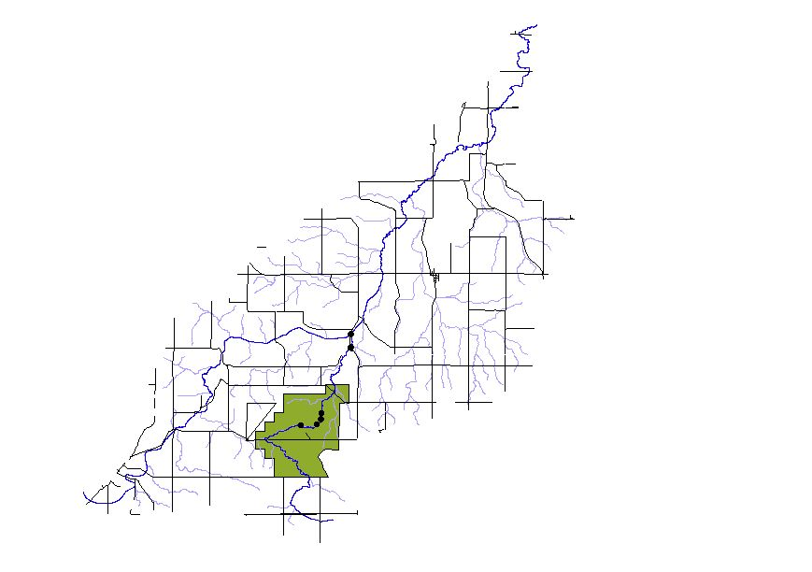
Figure 1. This displays a map of Prairie Creek and surrounding streams. The green highlighted area is Nerstrand State Park. Major roads of the area and sample sites are found in black.
Procedures
Within the park, we sampled mainly in the vicinity of Hidden Falls, the main attraction for visitors to the park. We took water samples above, directly below, and a few hundred yards downstream of the pool under the falls, to see what effects the falls and human interaction had on the Creek. In addition to these spots, we sampled at Oak Bridge, which is approximately 0.5 miles upstream of the falls. At this point, the Creek is more lethargic, slow moving, and semi-obstructed. Also, the landscape at the Bridge exhibits characteristics of a wet, low lying area, with pools of stagnant water and ferns abounding. Closer to Hidden Falls, the riverbed is carved out of limestone. Because of the fact that Prairie Creek does not exist solely within the park, we took samples at a pair of bridges on Minnesota Route 246 between Northfield and Nerstrand. One of these bridges was directly adjacent to a farm, the other a private residence.
At each sampling point, we used different tools and instruments to collect data from the creek at that particular time and place. Some instruments we brought with us, and we also took a water sample at each point that we could do further tests on chemicals in the water. We brought a YSI (Yellow Springs Instruments) meter with us to measure temperature, dissolved oxygen, conductivity, and sodium. Each of these things told us more about what kind of condition the creek is in. Temperature, measured in degrees Celsius, is related to oxygen levels and so helps determine the amount of life that the creek can support. Dissolved oxygen is measured in milligrams per liter. Levels above five milligrams per liter are optimal, and most fish cannot survive for long at levels below three milligrams per liter (Environmental Protection Agency, or EPA). Conductivity measures the amount of dissolved particles in the water. Sodium is currently under review by the EPA to see whether maximum levels will be set, however it is unlikely that levels in the water will be high enough for health risks. Currently the EPA has a 20 mg/L Drinking Water Equivalency Level (DWEL or guidance level).
We also brought a Secchi tube to every sampling point that we used to measure the turbidity of the water at that point. Turbidity is a measure of the clarity of the water; the amount of light that can reach the bottom of the creek affects both the temperature and the ability of the stream to support life. High turbidity levels are also often associated with higher levels of disease-causing micro-organisms. Water with large amounts of sediments are also more likely to disturb plants and animals in the stream (Tester, p.241). We also tested the pH at our sampling points, although we were only able to do this once during the sampling, using a pH meter to do this. pH can effect the taste of water, as well as the ability of the water to corrode. When CO₂ combines with water, it creates carbonic acid which dissolves the limestone bedrock of the creek and makes the pH more basic.
Water samples that were routinely collected at each sampling point were analyzed for seven anions using an Ion Chromatograph. Of these seven, five appeared as present in Prairie Creek. These were fluoride, chloride, nitrite, nitrate, and sulfate. The optimum amount of fluoride for drinking water is around one ppm (parts per million), (EPA). The application of phosphate fertilizers to soil dramatically increases fluorides in the soil which results in uptake by crops and contamination of drinking water through runoff. This chemical can be quite toxic. Chloride, in quantities above 250 mg/liter, can give a detectable salty taste to drinking water, although it is not a health risk. Nitrite is formed by bacterial reduction of nitrate to nitrite in a process of dentrification, and is a very serious pollutant in high concentrations. Typically, it enters the creek in runoff from fertilizer use; leaching from septic tanks, sewage; and erosion processes. The safe limit for Nitrite is one mg/L for drinking water (EPA). The most oxidized and abundant form of inorganic nitrogen in lakes and streams, however, is nitrate. This is a toxic chemical, the safe limit for drinking water is ten milligrams per liter (EPA). Its sources are the same as those for nitrite. Finally, sulfate can cause diarrhea and can have some aesthetic effects on taste and odor (EPA). It is a part of naturally occurring minerals in some soil and rock formations that contain groundwater. The mineral dissolves over time and is released into the groundwater. Secondary standards (effectively, standards that are not as closely limited, due to the mild nature of the chemical, and the high levels needed to produce any noticeable effect at all) are 250 mg/L or ppm (EPA).
Results
Based on our measurements, water analysis, and observations, we found that the composition and attributes of Prairie Creek between April 15 and May 14, 2003 (the period over which we sampled and analyzed the stream) had some distinct trends. Our measurements occurred in the spring when precipitation and snow melt are highest during the year and the composition of the stream is most likely to change considerably. It is also the time when runoff from the surrounding areas is still above ground in the streams and lakes, accurately demonstrating the effects of pollutants and precipitation on nearby groundwater every year. Due to the fact that each water collection site has different attributes it is necessary to describe the majority of our results specific to each site. All the measurements taken and data analyzed for Prairie Creek can be found for each site in appendix A.
At the first site, Bridge 1 along highway 246 near Estram Farm (figure 1), there was a drastic increase in the sulfate content of Prairie Creek after the first heavy rain of the season. The sulfate levels then decreased from 56.5782 mg/l to approximately 42-44 mg/l at sample days 2 and 3 and finally decreasing to 27.7422 mg/l. It is also beneficial to note that the sulfate content found in the sample from November 2002 (these data can be found listed in appendix A and occurred during a season when precipitation is very low) is much lower than the levels in spring 2003. The levels of nitrate at this location are also fairly low for the water sampling taken in November 2002. Our data shows an increase as the precipitation increases, the nitrate went from 10.6426 mg/l the first sample day to approximately (the numbers from samples 2 and 3 barely vary) 29mg/l, and then increased to almost double by the last day, 46.5957 mg/l. In the spring of 2003 the chloride levels found seem to be close to constant throughout sampling, fluctuating between 15.1467 and 18.3478 mg/l. The nitrite levels went from 0.2174 to 0 for the second and third sample days and finally appeared again in an equally small quantity, 0.2808 mg/l. There is also a similarly small fluoride content which changed very slightly between each sample day, fluctuating between 0.1313 and 0.1562 mg/l. This data is described in graph form in figure 2 below.
Figure 2. This graph describes the chemical levels measured by this project at the location Bridge 1 on highway 246 between the dates of April 15 and May 14, 2003.
At the second site, Bridge 2 along Hwy 246 (figure 1) the most noticeable point of interest is that the nitrate levels seemed to be somewhat constant and comparatively low until the last sampling day when they shot up from similar levels of days 2 and 3, from 32.3776 to 30.6434 mg/l, to 63.7127 mg/l on day 4 (it is important to note that we did not collect a sample from this site on the first day of sampling). The sulfate levels were much less than at the first bridge along Hwy 246, ranging from almost exactly the same level from day 2 to 3, 33.2545 to 33.8151 mg/l, and dropping on the fourth day of sampling, 18.1182 mg/l. Chloride levels remained similar to other sites, fairly stable, and fluctuating between 17.2275 and 15.8045 mg/l. The fluoride levels stayed somewhat constant throughout sampling similar to Bridge 1, fluctuating between 0.2006 and 0.1597 mg/l. There were no nitrite levels found at for this site until the final day of sampling, when it barely appeared at 0.2010 mg/l. This data is described in graph form in figure 3.
Figure 3. This graph describes the chemical levels measured by this project at the location Bridge 2 on highway 246 between the dates of April 15 and May 14, 2003.
At the third site, Bridge above Hidden Falls (figure 1), we found that the nitrate increased drastically over time from 7.7480 to 65.1754 mg/l, except only moderately between the samples from day 2 and day 3 when the levels remained similar, dropping just slightly from 40.5170 to 38.8781 mg/l. The sulfate levels at this location decreased through time, dropping from 44.8527 to 28.1203mg/l leveling between day 2 and 3 to 26.5755 mg/l and a largely dropping to 16.0131mg/l. The chloride content behaved similar to the first two sites, fairly consistent and fluctuating between 16.6212 and 18.1504 mg/l. Our results also showed that there was a slight amount of fluoride in each of the samples fluctuating between 0.1395 and 0.1924 mg/l. There were no nitrite levels apparent at this site until day 3 and 4 of sampling when they appeared at 0.1802 and 0.2352 respectively. This data is described in graph form in figure 4.
Figure 4. This graph describes the chemical levels measured by this project at the bridge directly above Hidden Falls between the dates of April 15 and May 14, 2003.
At the fourth data collection site, Hidden Falls (figure 1), there was considerable difference in many of the chemicals between the different sampling days. Nitrate levels increased drastically from 7.7959 to 63.8163 mg/l, except between days 2 and 3 when the decrease was slight, from 40.5170 to 38.8781 mg/l. The sulfate levels dropped consistently and drastically from 44.8142 to 17.7508 mg/l, except between days 2 and 3 again when the change was slight, from 28.0621 to 26.7716 mg/l. The chloride levels were consistent throughout at a similar level to the previous sites, fluctuating between 16.5419 and 17.9237 mg/l. Fluoride levels were generally found in very slight quantities throughout sampling, never increasing above 0.1838 mg/l. The nitrite levels came up in similarly slight quantities occasionally, although they were scattered throughout sampling days and never above 0.2260 mg/l. This data is described in graph form in figure 5.
Figure 5. This graph describes the chemical levels measured by this project directly beneath Hidden Falls between the dates of April 15 and May 14, 2003.
At the fifth data collection site, 100 yd below Hidden Falls (figure 1), the levels of all chemicals were fairly constant. Nitrate levels increased drastically at the last sampling day to 62.9015 mg/l, however they remained similarly low, from 41.0965 to 38.4948 mg/l, in comparison to other sites for the second and third sampling days (it is important to note that we did not draw a sample from this location on the first day of sampling). The sulfate levels decreased gradually from 28.1759 the second day to 26.6582 the third and then dropped to 17.8890 mg/l. The chloride levels were characteristically consistent throughout, fluctuating between 17.8403 and 16.5250 mg/l. There was a slight amount of fluoride throughout sampling, although never above 0.2079 and decreasing, and there were no nitrite levels at all for this site. This data is described in graph form in figure 6.
Figure 6. This graph describes the chemical levels measured by this project at a point approximately 100 yd below Hidden Falls between the dates of April 15 and May 14, 2003.
At the sixth data collection site, Oak Bridge (figure 1), there is little that changed significantly over the course of water sampling (it is important to note that we did not take a sample from this location on the first day of sampling). The nitrate levels were higher than the other chemicals at this location, close to equal from the second to the third sample days, 42.5443 41.4854 mg/l respectively, and increased drastically by day 4 of sampling to 65.1250 mg/l. Sulfate levels remained fairly consistent and dropped just slightly over time from 24.0614 to 22.6343 to 16.0616 mg/l. Chloride, once again, remained very consistent throughout sampling, dropping just slightly on day 3 and then increasing slightly on day 4, fluctuating between 16.7379 and 18.1364 mg/l. There was a small amount of fluoride throughout sampling, never measuring more than 0.1896 mg/l, similar to all sites of data collection. Nitrite appeared at very slight levels above 0 after day 3, measuring 0.1990 and then 0.1889 mg/l. This data is described in graph form in figure 7.
Figure 7. This graph describes the chemical levels measured by this project at Oak Bridge between the dates of April 15 and May 14, 2003.
On a more general level there were certain attributes of the stream bed itself that we noted changing throughout the time we spent sampling water. As precipitation continued through the spring season the turbidity and water level increased. The total precipitation, measured by rainfall, in the month of March, 2003 was 1.24 inches (figure 8). The total rainfall in April before 4/15/2003, directly preceding our sampling, was 0.37 inches. Between the first and second sample there were exactly 1.55 inches of rainfall. Between the second and third samples there were exactly 1.55 inches of rainfall. And between the third and fourth samples there were exactly 3.07 inches of rainfall. This data can be found in figure 8 below. In addition, the daily rainfall for the months of April and May 2003 can be found described in figure 9 below.

Precipitation for Rice County During Water Sampling of Prairie Creek
(Measured in inches of Rainfall)
 |  |  | Inches of Rainfall
Sample Dates:
4/15/2003 |  |  | 0.33
4/23/2003 |  |  | 0.00
5/6/2003 |  |  | 0.00
5/14/2003 |  |  | 0.28
Total between Sample Dates:
4/1/2003 - 4/15/2003 |  |  | 0.37
4/15/2003 - 4/23/2003 |  |  | 1.55
4/23/2003 - 5/6/2003 |  |  | 1.55
5/6/2003 - 5/14/2003 |  |  | 3.07
Figure 8. This data table displays the inches of rainfall for each day samples were taken from Prairie Creek. It also displays the total inches of rainfall in the month before the first sample was taken and between each consecutive sample.

Prairie Creek also showed a great deal of sedimentary deposits along the creek bed, especially at the sites of higher turbidity towards the end of our sampling when precipitation was the greatest. Oak Bridge had an especially high amount of sediments, as well as the site 100 yd below Hidden Falls where a large sand bar formed on one side of the stream. The other areas were too turbid for sedimentary deposits but did show that there was a great deal of sediment in the water based on increasing turbidity levels throughout sampling.
Figure 9. This graph displays the total daily inches of rainfall for the months of April and May 2003.

Discussion
We found several aspects that were pertinent to this discussion of the water quality of Prairie Creek. The first was the difference in composition of the water inside versus outside Nerstrand Park. This helped us to determine what effect farming has on the water. Second, we noticed that the chemical levels changed over time, which led to hypotheses regarding the source of the chemicals. Finally, we looked at how the geography of the area and the level of precipitation may have affected the water quality.
Our expectations for the difference in water quality inside and outside the park were that inside the chemical content of the stream would be noticeably better due to the added attention given to the environment inside a state park. Some examples of this increased attention include letting natural forest growth occur, as opposed to the heavily and repeatedly cultivated farmland outside the park. As part of this element, the park also has significantly lower levels of fertilizer and chemical run off that would occur on a farm setting. Our results showed support for this hypothesis, as sample sites 1 and 2, outside the park, showed overall higher levels of nitrate and sulfate than the sample sites within the park. Nitrate and sulfate are both minerals indicative of fertilizer pollution. The chemical elements that were detected in Prairie Creek are as follows: Sulfate, Nitrate, Nitrite, Chloride and Fluoride. Sulfate levels in Prairie Creek started at an elevated level, and dropped at each successive sampling date. The reason for this, we believe, is that the large amount of precipitation that occurred during this study diluted the natural level of sulfate in the water, which can be attributed to pyrite and limestone in the riverbed.
Nitrite levels in Prairie Creek were extremely low, due to the fact that any amounts of this chemical are almost instantly transformed into Nitrate. Nitrate levels are controlled in streams such as this mainly by human processes such as farming (Tester 241). Runoff from fields that have been fertilized often contains extremely high levels of nitrate. Evidence of this can be seen in the overall rise of nitrate levels throughout our study. When we began, farming processes were just beginning, and as we ended, plant life and farming were in full swing. The EPA has deemed 10 mg/L to be the standard for gross amounts of nitrogen (represented in our graphs by Nitrate-N) allowable in drinking water (in higher concentrations it can become toxic). Prairie Creek was universally quite close to, and more often than not actually within this standard. This is most likely attributable to the fact that the creek flows through areas generally further from farming than most streams and rivers in this area.
In terms of the local geological activity, the most interesting area is Hidden Falls, which is a limestone formation. The banks on either side of the river extending slightly up and down (further downstream) stream from the falls are mainly limestone as well. This is made obvious by not only the clear interaction between the rock and the stream (the natural acidity of rainwater often erodes limestone), but also by the actual appearance of the rock. In fact, a short distance downstream from the test site below hidden falls is an incidence of Karst topography, where we observed a small water trickle appearing from what appeared to be solid rock.
The limestone nature of this area may have an effect on the pH of the water. Generally speaking, within the park, the pH is very close to neutral, while outside of the park it is noticeably more basic. PH is controlled by the bedrock in this case, because when the carbon dioxide forms carbonic acid, it dissolves the limestone, which is basic in nature. So a good way to determine the pH of the stream at any given point (without a meter) is to look at what kind of rocks are underneath the stream.
There were two significant rainfalls during our study. The first was between April 15th and 19th, with a total of over 1.5 inches of rain falling. The second was between May 6th and 11th, with well over 2 inches falling. Water levels increased and clarity decreased throughout, however in the last sampling day we noticed an abrupt and significant change. Rocks that were previously entirely exposed were submerged, and we were only able to see roughly 10 centimeters into the water. Also, an entire sandbar piled up near a sampling site within one week. Based on this, we make the observation about sulfate mentioned above. We also noted the increased erosion of stream banks, the increased amount of suspended matter in the water, and the faster motion of the stream itself.
Conclusion
Based on our results and discussion, we are able to make some selected conclusions and recommendations for possible further study of Prairie Creek. We can safely conclude that in a general sense, Prairie Creek is in good health. Levels of contaminants are if not within guidelines, close to them. Evidence of life is abundant throughout. We noted small aquatic life on several occasions.
Absent from our study is a discussion and evaluation of E. Coli bacteria present in Prairie Creek. In years past, levels have been found to be well in excess of those deemed safe by the EPA (Bartolomeo et al). However, we felt that it was not necessary to actually determine current levels of this contaminant, because it has been so extensively studied, its causes determined (the beaver damn upstream of Hidden Falls was the main culprit. We were actually unable to find said dam, and water flow seems to be quick in all areas), and its effects have been historically mild.
However, we would include an investigation of the E. Coli status in Prairie Creek in future studies, perhaps 3 to 5 years in the future. In addition to this exploration, we suggest that further studies more closely examine the dichotomy between water chemistry inside the park and outside. A more conclusive study on this dichotomy would further explore the separate fork of the creek that does not flow through the creek. Finally, we would recommend that any conclusive study start earlier in the year, and end later. While we were able to clearly observe the creek in flux, with farming processes and rainfall starting in earnest, but we are unable to state conclusively what the “natural” state of the creek is during times of less drastic change, such as later in the summer.
Acknowledgements
We would like to thank Bereket Haileab for his extensive help and direction, and Nerstrand Big Woods State Park for the use of their land. Also, Liz Clark, for her help with our samples and GIS, lab assistants Heather Hilchey and Melissa Keevil, for their support, and to Lina Dorris, for driving us. Finally, our thanks to the study done in 2001-2002 by the students from Smith College, Pomona College, and the College of Wooster for giving us an example and a precedent.
References

"Water Quality in the Upper Mississippi River Basin, Minnesota, Wisconsin, South Dakota, Iowa and North Dakota, 1995-98." USGS Survey <http://water.usgs.gov/pubs/circ/
circ1211/ pdf/circular1211.pdf>

"E. coli Source Tracking by Rep-PCR DNA Fingerprinting." Department of Soil, Water, and Climate, Room 439 BorH, 1991 Upper Buford Circle, St Paul, MN 55108. University of Minnesota, 2000. <http://www.ecolirep.umn.edu/index.htm>

"Regional Total Maximum Daily Load Evaluation of Fecal Coliform Bacteria Impairments in the Lower Mississippi River Basin in Minnesota." N. Senjem, et al. Minnesota Pollution Control Agency, Regional Environmental Management Division, US Environmental Protection Agency Region 5, Chicago, Illinois, Oct 2002.

"Water-Quality Parameters and Benthic Algal Communities at Selected Streams in Minnesota August 2000 - Study Design, Methods and Data." US Department of the Interior, US Geological Survey.

“A Study of Plant Macrofossil Taphonomy in Prairie Creek, Nerstrand Big Woods State Park, Rice County, Minnesota.” Strickland, Laura E., Baker, Richard G. The Geological Society of America, 31st annual North-Central Section, Madison, WI, United States, May 1-2, 1997. http://georef.cos.com/cgi-bin/getRec?un=2000-041219

“Ground Water & Drinking Water” Environmental Protection Agency. http://www.epa.gov/safewater

“Geomorphology and Water Quality of Prairie Creek in Nerstrand Big Woods State Park, Minnesota” 2001, Eleanor Bartolomeo, Adam Meyers, Nick Welty.

Tester, John R. Minnesota’s Natural Heritage: An Ecological Perspective 1972, University of Minnesota Press, Minneapolis, Minnesota

Cannon River Study: Physical and Chemical Properties
Nat Beebe, Kirstin Duffin, Anna Layman, Emily Schwing
June 2, 2003

Introduction
This study analyzes the Cannon River in and near Northfield and Faribault, Minnesota. Our group took water samples between April 15, 2003 and May 13, 2003 to determine the water quality; this research adds to the body of literature that already exists on the Cannon. In 1996 the Cannon River Watershed Partnership did a study to monitor the river water. Three Carleton students, Joel G. Schilling, John Colman, and Kathleen Kopach, did their comprehensive exercises on the Cannon in 1976. Their results can be found in the Carleton College Gould Library, along with the Cannon River Watershed Partnership data. The United States Geological Survey has also collected data on the Cannon River available online.
While collecting water samples from six different sites in and around Northfield and Faribault, we conducted readings on the Cannon for temperature, turbidity, salinity, pH levels, conductivity, and dissolved oxygen. We also tested the water samples for the following nutrients: sulfate, fluoride, chloride, bromide, nitrite, nitrate and phosphate. See appendix A for the test results. Using EPA standards we compared the Cannon test results to healthy nutrient levels of drinking water.
We were able to determine some contaminants in Cannon River water and their possible origins. As a viable water source for human consumption in Rice County, the actions of the Cannon River watershed affect the community. We have analyzed the results of five weeks of water samples to determine that the Cannon River water presents nutrient levels below EPA drinking water standards; this study also shows that the Cannon River generally acts in explainable patterns.

Methods and Instruments
Yellow Springs Instruments Incorporated, model 85 (YSI-85) - This was the primary instrument used at each field site. The YSI-85 was used to measure conductivity, temperature, dissolved oxygen, and salinity. The YSI-85 collects measurements by placing a probe into the water sample, which then displays the readings onto a hand held module. The YSI-85 was efficient in gathering data in the field.
pH meter - This instrument was used to measure both the pH and temperature of the water sample. The pH meter presents data by placing a probe into the water sample, and then displaying the readings onto a hand held module. The pH meter was very helpful in the field and eliminated the need to test the pH levels by hand.
Secchi tube - We used this instrument to determine the turbidity of the water sample. The Secchi tube is a long tube made out of a clear plastic, which at the bottom has a white and black disc attached. In order to measure turbidity, the tube is first filled full with water from the sample site. Next, water is released out of the tube by opening a valve, which lets water flow out through a smaller tube installed near the bottom. As the water is released out of the Secchi tube, the black and white disc begins to appear. When both the black and white parts of the disc are visible, the valve is shut. To determine the turbidity level, a ruler is attached to the outside of the Secchi tube and measures the distance from the disc to the water level. The water clarity is clear if the measurement on the Secchi tube is high.
Ion Chromatograph - This instrument was used to measure Phosphate, Chloride Fluoride, Bromide, Sulfate, Nitrite, and Nitrate. To test for these elements, the water samples must be collected from the site and then brought back to the machine for analysis. Once the water has been collected it must be forced through a small mesh screen in order to filter out fine sediments and other materials, which might clog the Chromatograph. After the water sample has been filtered it is placed in the Chromatograph, which measures each of the elements and displays the information in a graph. This information is stored in a computer and later can be printed out. The Ion Chromatograph is a very precise machine, which can measure one water sample in about eight minutes, and it is the same machine that Environmental Protection Agency uses to test drinking water.
Test Sites

We consistently tested five sites: Rice Creek, Wolf Creek, Highway 3, Faribault, the Northfield Dam, and Lyman Lakes. All were located within or between Northfield, Minnesota and Faribault. Additionally, we collected one sample at each of two additional sites: the Mississippi and above Lyman Lakes.
Rice Creek - This site is located about .5 miles West of the junction of Highway 3 and Highway 19 in Northfield, MN. Water samples were taken a few meters downstream of where Rice Creek flows into the Cannon River to ensure the sample was water from the Cannon River and not merely Rice Creek water. A total of six samples was collected from the Rice Creek sample site from April 15, 2003 thru May 13, 2003.
Wolf Creek - This site is located approximately 2 miles West of Northfield, MN off of Highway 3. Water samples were taken a few meters downstream of where Wolf Creek flows into the Cannon River. A total of six samples was collected from the Wolf Creek sample site from April 15, 2003 thru May 13, 2003.
Highway 3 - This site is located off the side of Highway 3, at mile marker 5. Water samples were taken from the bank of the Cannon River in the first wooded area a few meters west of mile marker 5. After several weeks of heavy rain, this site became flooded and forced us to take the water sample closer to the road on our last sampling date. A total of six samples was collected from the Highway 3 sample site from April 15, 2003 thru May 13, 2003.
Faribault - This site is located off Highway 3 in downtown Faribault, MN directly behind the Faribault foods factory. Water samples were initially taken directly on the stream banks, but do to heavy rains each subsequent sample was taken farther away from the initial location. Five water samples were collected from the Faribault sample site from April 22, 2003 thru May 13, 2003.
Northfield Dam - This site is located in downtown Northfield, MN. Water samples were taken a few meters above the Dam, directly across from the Northfield Post Office. Six water samples were collected from the Northfield Dam site from April 15, 2003 thru May 13, 2003.
Lyman Lakes - This site is located off Highway 19, near Carleton College. Water samples were taken a few meters downstream of where the Lyman Lakes stream flows into the Cannon River. Lyman Lakes are located on the campus of Carleton College and are often home to hundreds of geese in the fall. Three water samples were collected from the Lyman Lakes site from April 22, 2003 thru May 13, 2003.
Mississippi – This site is in Redwing, Minnesota, where the Cannon River joins the Mississippi River. One water sample was taken here on May 10, 2003.
Above Lyman Lakes – This site is along the stream that feeds into Lyman Lakes, dividing the Carleton College soccer fields and the Carleton arboretum. We sampled water approximately 10 meters below the dam in the stream and ten more meters before the stream empties into Lyman Lakes. This site was tested once on May 13, 2003.

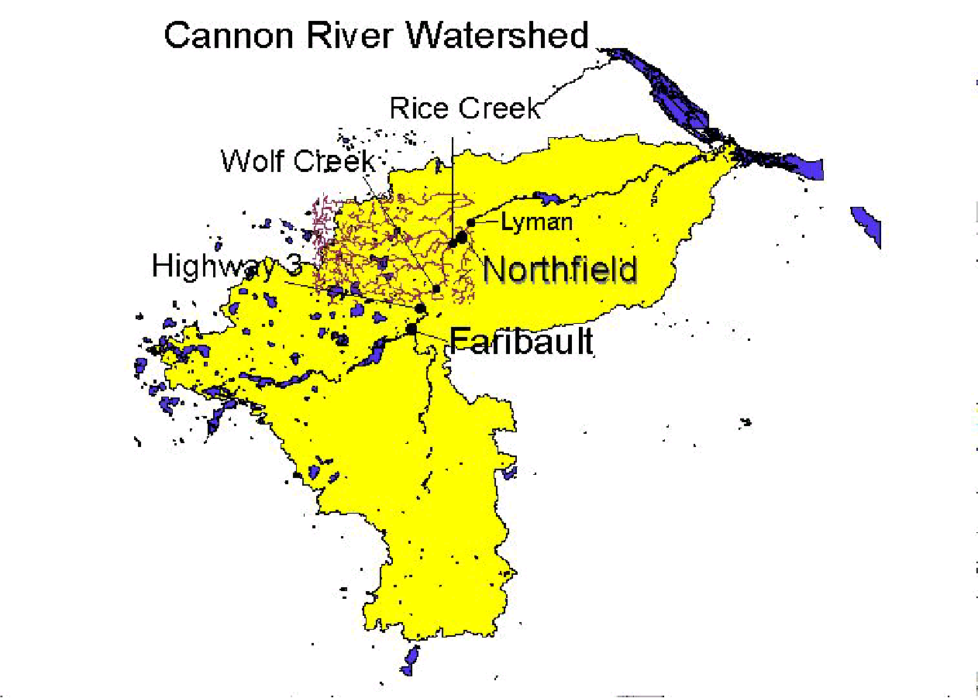
Figure 1 – Test Sites

Observations
A healthy water source is able to sustain many different forms of plant and animal life. We determined the Cannon River does support many thriving organisms. While visiting our test sites along the river, we saw an abundance of animal life. Over the course of our study, we saw heron, carp, ducks, geese, and turtles. In collecting water samples, some days we found water boatmen and other small organisms swimming in the water; we also found a snail’s shell near the river. One day, we discovered a dead bullhead floating near the bank. Floating near it was another sickly bullhead. Confused as to why this might be, we propose that the extended period of rain may be in part to blame. A decreasing level of dissolved oxygen is another possible cause. Fish are healthy if the dissolved oxygen level is above 5 mg/L (Haileab, handout). While we found the dissolved oxygen to be above this amount, Figure 6 shows that the level is rapidly declining. The fish may not have been able to adjust to this change.
One source of pollution to the river, mentioned briefly above, is flooding. Over the course of our study of the Cannon River, it was possible to watch the impact of precipitation on the river’s water and contaminant levels. With almost total consistency, the Cannon got progressively deeper each time we visited. Spring rains make flooding a common occurrence (Figure 4). The total precipitation during our study was approximately 21 centimeters, or a little over 8 inches (The Weather Underground, Inc.). The river level rose much more than this. Rain draining from the land, and streams feeding into the Cannon caused the additional rise in water level.
Results
Through testing six different points along the Cannon River, as well as three areas of water that either influence or are influenced by the Cannon, we have observed patterns and results. Figure 2 shows the changes in water temperature. For most sites it decreased from highs of 19.2 degrees Celsius over the dam in Northfield and 18.5 degrees Celsius at Rice Creek and on Highway 3 on April 15 to fluctuate between 10 and 15 degrees toward the end of the testing period, rising to a high of 16 degrees in Faribault on May 13. Warming temperatures were the general trend.

Figure 2 – Water Temperature of Cannon

Turbidity levels of the Cannon River fluctuated throughout the month of testing (Figure 3). Several rainstorms helped to raise the level of the river. The river’s velocity increased during our study. After rainstorms the velocity of the main current increased; however, when the floodplains flooded, the water lying there was fairly stagnant. At the Highway 3 and Northfield Dam test sites, the turbidity levels increased from April 15 to April 22, rising from 35.2 on Highway 3 to 86.8 and 46.2 at the Dam to 79. The turbidity levels tended to decrease at those two sites, as well as at Rice Creek until May 9, when all of the turbidity levels rose, except for the level at the Northfield Dam, which continued to decrease from 85.6 on April 26 to 18.8 on May 13. Wolf Creek, Rice Creek, and the Cannon at Faribault all followed similar turbidity level patterns. The Faribault site consistently maintained some of the highest turbidity levels, reaching the highest recorded level for any site on May 13 at 95.6. While Wolf Creek followed a similar pattern, it reached the lowest turbidity level recorded on May 9 at 6.8, the same day that almost every point on the Cannon reached its lowest level. To analyze how the turbidity level of each site compares with the others, see the chart below. Figure 4 contains data from the Carleton College website, and it portrays the levels of rain in Northfield throughout the testing period.

Figure 3 - Turbidity Measurements
Figure 4 – Precipitation during April 14, 2003- May 15, 2003

Salinity levels for the Cannon River remained fairly steady, at 0.1 ppt to 0.3ppt. Wolf Creek, Rice Creek, and the Faribault site remained steady at 0.2 ppt, while the Northfield Dam and Lyman Lakes’ entry into the Cannon stayed steady at 0.3ppt. The salinity at the Highway 3 site showed the only drastic change, jumping from 0.1 to 0.3 between April 15 and April 22 and then remaining steady at 0.3 for the duration of the project.
The pH levels of these sites on the Cannon all were measured and mostly found to be basic. Rice Creek’s pH changed from 8.29 on April 26 to 8.65 on May 13. The pH on Highway 3 climbed similarly from 7.9 to 9.8. Wolf Creek’s pH, however, changed in the other direction, dropping from a pH of 8.0 on April 26 to 7.3 on May 13. At the Northfield Dam, the basic pH of 10 on April 26 dropped to 7.3 on May 13. Meanwhile, in Faribault the pH made a similarly sized jump in the other direction, going from a slightly acidic 6.9 to a very basic pH of 10. The researchers also measured the pH at Lyman Lakes’ entry to the Cannon at an acidic 6.65, while the pH of the stream above Lyman Lakes was 7.93 on the same day.
Conductivity levels of the Northfield Dam location, Lyman Lakes water at the Cannon, and Highway 3 all hovered between approximately 400 and 500 with Highway 3 reaching the high of 505 us on April 22. The Faribault site, Wolf Creek, and Rice Creek all maintained lower conductivity levels, ranging from Wolf Creek’s low on April 22 of 278 us to Rice Creek’s high of 366 us on May 9. Each site increased its level of conductivity between May 6 and May 9 with the exceptions of Wolf Creek, which declined from 355.3 us to 325 us and the Northfield Dam, which remained steady at 457 us. Likewise, from May 9 to May 13, every site’s conductivity declined with the exception of the Faribault site, which increased from 327 us to 339.7 us. Figure 5 below illustrates these findings.

Figure 5 – Conductivity Measurements
The Northfield Dam site, Rice Creek, Lyman Lakes in the Carleton Arboretum, Faribault, and Wolf Creek follow a similar downward trend in dissolved oxygen levels. With the highest beginning level of 15.73 mg/L, the Northfield Dam’s level decreased throughout the testing period, ending on May 13 at a level of 6.22 mg/L. Wolf Creek’s similar decreasing trend at the end of the project with the lowest level of 4.4 mg/L. The site at Highway 3’s levels were much more erratic, jumping from 8.51 on May 6 to 17.4 mg/L on May 9, and then falling back to 6.7 mg/L on May 13. See Figure 6 below for complete results.

Figure 6 – Dissolved Oxygen

Using the Ion Chromatograph, the researchers tracked the levels of certain components in the stream water. Throughout the testing period, the levels of sulfate at every location dropped considerably from their initial levels on April 15. The Highway 3 site’s level changed the most, ranging from the data’s overall high of 38.0395 mg/L down to the data’s overall low for sulfate at 16.3511 mg/L on May 13. Wolf Creek’s sulfate levels stayed between 24.012 mg/L on April 15 and 20.2004 at the end of the testing. Figure 7 displays the pattern of generalized sulfate content decline. The only nutrient that showed up in a significant amount in the well water sample was sulfate; there were 16.0478 mg/L.

Figure 7 – Sulfate in mg/L

According to the Environmental Protection Agency, drinking water must have less than 4.0 mg/L of fluoride (List of Drinking Water Contaminants & MCLs, 2003). All of the samples along the Cannon River were far below this level; the highest level measured was 0.5514 at the last sampling of Rice Creek. This sample, however, is much higher than the other samples taken, most of which hovered between 0.1 and 0.2 mg/L. Highway 3 samples consistently had higher levels of fluoride than the other sites’ samples, and the samples taken from the dam consistently were not far below. Figure 8 shows all fluoride measurements.

Figure 8 – Fluoride in mg/L

Similar to the fluoride measurements, the chloride levels remained fairly consistent. 250 mg/L is the Secondary Standard put forth by the EPA (List of Drinking Water Contaminants & MCLs, 2003), and once again, the chloride levels in our samples did not reach that level. The chloride content declined similarly between April 15 and April 22 for Highway 3 and the Northfield Dam, moving from 37.5844 mg/L by Highway 3 to 27.8657 mg/L. Likewise, both Rice Creek and Wolf Creek’s chloride levels increased by a very small amount, Wolf Creek’s rising from 14.6319 mg/L to 14.8685 mg/L. All chloride levels began to decline at the May 6 sampling with Wolf Creek eventually reaching the lowest level on May 13 at 13.0609 mg/L. The trends are illustrated in Figure 9.

Figure 9 – Chloride in mg/L

The nitrite levels of all the test sites were reasonably low. Several times during sampling no nitrites are found in the water. When nitrites are found in the water, the concentration is very low. Figure 10 illustrates that the highest concentration was 0.13 mg/L, which we took from Lyman Lakes on May 13. The Northfield Dam had the most consistent nitrite levels with nitrites in the water five out of the six testing day. Even though the Dam was consistent in reading, the levels always remained under 0.12 mg/L. Figure 10 – Nitrite in mg/L

The nitrate levels unlike nitrite ranged in concentration depending on the site. The Northfield Dam and Highway 3 samples had the highest concentrations ranging from 2 mg/L all the way up to 8 mg/L. In fact the concentrations of these two sites seem very similar, almost running parallel to each other. The lowest concentration occurred in Faribault, which highest level was only 1.11 mg/L. The Faribault test site was always very low in nitrates and only increased above 0.4 mg/L once. Wolf Creek seemed to fall in the middle of all the other sites. It never reached too high of levels, its maximum being 3.7 mg/L, but on the same hand Wolf Creek was always above 1 mg/L. Although the sites all had varying degrees of concentration, as is illustrated in Figure 11, they all seemed to increase in concentration as testing went on.
Figure 11 – Nitrate in mg/L

Discussion
There are a number of possible sources of error for our study on the Cannon River. Although slight, there is always human error when taking measurements, especially with instruments like the Secchi tube. Also, a few times, our pH meter was not calibrated and, therefore, may have altered our results. Variation in our results occurred for multiple reasons, including seasonal change. After heavy rain at the end of April, the level of the river rose to the point where we were not able to reach the same locations from which we had taken samples previously. Also, the rainwater might have changed the levels of nutrients in the river water. Wildlife residing where we took or samples from may also have caused change in nutrient level, so we were never testing 100% river water.
The well water came directly from Jordan Sandstone; therefore, it was not as polluted by rainwater and runoff. The Cannon River is a tributary to the Mississippi River. The Cannon thus contributes to the Mississippi's physical and chemical properties. Chloride levels in the Mississippi are not as high as in many parts of the Cannon. A higher volume of water flows in the Mississippi than in the Cannon, so the Mississippi's nutrients may be diluted in comparison. To examine the differences between Carleton College well water from Jordan Sandstone, water from the Mississippi, and the samples taken from the local Cannon River, see Table 1 in Appendix A.
If we were to do this study again, there are a few things we would do differently. We would sample at different test sites. For example, there is a wastewater treatment plant located on the river in Dundas. Also, we would choose sampling locations at places more consistently in the river’s current, and we would sample each site at the same time of day.

Conclusion
The Cannon River passes the Environmental Protection Agency’s requirements for healthy drinking water. Nonetheless, there are low levels of contaminants in the river. To understand why this may be, we look at where are test sites are located and what else is around the area. Our test site in Faribault may have been contaminated by factory output from the foods factory situated on the banks of the Cannon River. The Highway 3 site might have been contaminated by the road use. Road salts and other vehicle pollution may have drained into the river. The site in Northfield is most likely contaminated by urban sprawl. Located in downtown Northfield, we noticed much litter by the banks of the river. The Rice Creek and Wolf Creek sites were the areas most affected by wildlife. To make sure the river water remains safe, the levels of contaminants should continue to be monitored.

Acknowledgements
Thank you to Liz Clark for teaching us how to use the GIS program in order to put our information together. Thank you also to Heather Hilchey for driving us to our test sites to collect data. Thank you to Ben Harrison for explaining how to put our projects together for display. We thank Joseph Graly and Heather Hilchey for editing our paper. Thank you, Bereket Haileab, for teaching us that projects like this one make a difference.

References
“Cannon River.” Minnesota Department of Natural Resources.
<http://www.dnr.state.mn.us/canoeing/cannonriver/index.html> (21 Apr. 2003).
“Cannon River.” National Watershed Network. July 10, 2000.
<http://www.ctic.purdue.edu/cgi-bin/ ShowWatershed.exe?Watershed=Cannon+River+%28USGS%23%3A+07040002%29> (May 21, 2003).
“Cannon River Watershed Partnership.” Cannon River Watershed.
<http://nco.northfield.mn.us/crwp/> (06 May 2003).
“Cannon Watershed Profile.” United States Environmental Protection Agency.
<http://cfpub.epa.gov/surf/huc.cfm?huc_code=07040002 > (07 May 2003).
“Did You Know?” Cannon River Watershed Partnership.
<http://www.crwp.net/facts.html> (21 Apr. 2003).
Haileab, Bereket. “What are We Measuring and Why?” Handout, p. 2.
Kroening, Sharon and James Stark. “Variability of Nutrients in Streams in Part of the
Upper Mississippi River Basin, Minnesota and Wisconsin.” United States
Geological Survey Fact Sheet FS-164-97.
<http://mn.water.usgs.gov/164-97/text.htm> (24 Apr. 2003).
“List of Drinking Water Contaminants & MCLs.” U.S. Environmental Protection
Agency. 6 Mar. 2003. <http://www.epa.gov/safewater/mcl.html> (28 Apr. 2003).
“Northfield, MN.” Wunderground.com.
<http://www.wunderground.com/US/MN/Northfield.html> (26 May 2003).
“Removal of the Welch Dam.” American Rivers.
<http://www.amrivers.org/tableofcontents/sscannon.htm> (21 Apr. 2003).
“U.S. Geological Survey. 1990 Water Use for 07040002 – Cannon.” U.S.
Environmental Protection Agency. <http://water.usgs.gov/cgi-bin/wuhuc?huc=07040002> (28 Apr. 2003).
Appendix A
Table 1: Analysis of Cannon River Test Sites – Physical and Chemical Properties
Testing Site |  | Date |  |  | Color |  |  |  | Air Temp. | Water Temp.
 |  |  |  |  |  |  |  |  | centigrade | centigrade
Rice Creek |  | 15-Apr |  |  | red/tan/brown/clear |  |  |  | 25.5 | 18.5
 |  | 22-Apr |  |  | red brown |  |  |  | 20.5 | 11.3
 |  | 26-Apr |  |  | yellow brown |  |  |  | 24.0 | 13.8
 |  | 6-May |  |  | mossy |  |  |  | 24.0 | 13.1
 |  | 9-May |  |  | clay |  |  |  | 21.0 | 13.2
 |  | 13-May |  |  | green tan |  |  |  | 22.0 | 15.2
Wolf Creek |  | 15-Apr |  |  | muddy brown |  |  |  | 29.6 | 18.5
 |  | 22-Apr |  |  | muddy brown |  |  |  | 20.5 | 11.7
 |  | 26-Apr |  |  | brown/army green |  |  |  | 26.7 | 13.3
 |  | 6-May |  |  | muddy brown |  |  |  | 16.6 | 14.4
 |  | 9-May |  |  | cocoa brown |  |  |  | 17.0 | 12.5
 |  | 13-May |  |  | brown/gray |  |  |  | 31.0 | 14.7
Highway 3 |  | 15-Apr |  |  | brown |  |  |  | 25.5 | 18.5
 |  | 22-Apr |  |  | beige/brown |  |  |  | 18.0 | 11.6
 |  | 26-Apr |  |  | yellow brown |  |  |  | 24.0 | 13.6
 |  | 6-May |  |  | greenish mud |  |  |  | 19.0 | 10.9
 |  | 9-May |  |  | mud brown green |  |  |  | 21.0 | 12.5
 |  | 13-May |  |  | green brown |  |  |  | 31.0 | 12.5
Faribault |  | 22-Apr |  |  | gray brown |  |  |  | 19.0 | 14.3
 |  | 26-Apr |  |  | green brown |  |  |  | 23.6 | 15.0
 |  | 6-May |  |  | clear green |  |  |  | 19.7 | 14.7
 |  | 9-May |  |  | mud green |  |  |  | 21.0 | 15.4
 |  | 13-May |  |  | gray green |  |  |  | 31.0 | 16.0
Northfield Dam |  | 15-Apr |  |  | green brown |  |  |  | 26.0 | 19.2
 |  | 22-Apr |  |  | brown |  |  |  | 20.7 | 12.0
 |  | 26-Apr |  |  | green brown |  |  |  | 22.0 | 14.5
 |  | 6-May |  |  | tan/murky gray |  |  |  | 18.0 | 12.3
 |  | 9-May |  |  | gray tan |  |  |  | 17.0 | 12.8
 |  | 13-May |  |  | gray mud |  |  |  | 31.0 | 12.7
Lyman Lakes |  | 22-Apr |  |  | muddy brown |  |  |  | 20.7 | 13.4
 |  | 9-May |  |  | green brown |  |  |  | 17.0 | 13.1
 |  | 13-May |  |  | tan gray |  |  |  | 31.0 | 13.4
Mississippi River |  | 18-May |  |  | rusty brown |  |  |  | 24.3 | 17.9
Above Lyman Lakes |  | 13-May |  |  | gray |  |  |  | 31.0 | 17.2
Well Water |  | 15-May
Testing Site | Date |  | Turbidity |  |  | Salinity | pH | Conductivity |  |  | Dissolved Oxygen
 |  |  | cm |  |  | ppt |  | us |  |  | mg/L
Rice Creek | 15-Apr |  | 83.6 |  |  | 0.2 |  |  |  |  | 11.85
 | 22-Apr |  | 56.8 |  |  | 0.2 |  | 324.0/433.0 |  |  | 11.70
 | 26-Apr |  | 58.8 |  |  | 0.2 | 8.29 | 303.0/384.0 |  |  | 11.72
 | 6-May |  | 51.4 |  |  | 0.2 |  | 358.4/464.1 |  |  | 9.07
 | 9-May |  | 16.2 |  |  | 0.2 |  | 366.0/473.0 |  |  | 9.15
 | 13-May |  | 53.2 |  |  | 0.2 | 8.65 | 360.0/443.0 |  |  | 5.95
Wolf Creek | 15-Apr |  | 75.0 |  |  | 0.2 |  |  |  |  | 11.85
 | 22-Apr |  | 37.3 |  |  | 0.2 |  | 278.0/375.0 |  |  | 8.90
 | 26-Apr |  | 38.6 |  |  | 0.2 | 8.00 | 290.0/375.0 |  |  | 11.54
 | 6-May |  | 59.8 |  |  | 0.2 |  | 355.3/444.5 |  |  | 9.72
 | 9-May |  | 6.8 |  |  | 0.2 |  | 325.0/419.0 |  |  | 7.70
 | 13-May |  | 26.8 |  |  | 0.2 | 7.30 | 300.0/375.0 |  |  | 4.40
Highway 3 | 15-Apr |  | 35.2 |  |  | 0.1 |  |  |  |  | 13.68
 | 22-Apr |  | 86.8 |  |  | 0.3 |  | 505.0/682.0 |  |  | 8.19
 | 26-Apr |  | 83.2 |  |  | 0.3 | 7.90 | 485.0/617.0 |  |  | 11.00
 | 6-May |  | 35.4 |  |  | 0.3 |  | 408.0/558.0 |  |  | 8.51
 | 9-May |  | 22.9 |  |  | 0.3 |  | 469.0/612.0 |  |  | 17.40
 | 13-May |  | 25.5 |  |  | 0.3 | 9.80 | 407.0/535.0 |  |  | 6.70
Faribault | 22-Apr |  | 83.8 |  |  | 0.2 |  | 327.0/411.0 |  |  | 9.30
 | 26-Apr |  | 81.8 |  |  | 0.2 | 6.90 | 335.0/410.0 |  |  | 9.70
 | 6-May |  | 91.2 |  |  | 0.2 |  | 327.0/410.0 |  |  | 16.40
 | 9-May |  | 56.1 |  |  | 0.2 |  | 339.7/415.0 |  |  | 5.22
 | 13-May |  | 95.6 |  |  | 0.2 | 10.00 | 357.0/431.0 |  |  | 5.40
Northfield Dam | 15-Apr |  | 46.2 |  |  | 0.3 |  |  |  |  | 15.73
 | 22-Apr |  | 79.0 |  |  | 0.3 |  | 445.0/588.0 |  |  | 11.40
 | 26-Apr |  | 85.6 |  |  | 0.3 | 10.00 | 479.0/598.0 |  |  | 10.80
 | 6-May |  | 37.9 |  |  | 0.3 |  | 457.0/605.0 |  |  | 9.94
 | 9-May |  | 21.9 |  |  | 0.3 |  | 457.0/597.0 |  |  | 8.40
 | 13-May |  | 18.8 |  |  | 0.3 | 6.73 | 400.0/542.0 |  |  | 6.22
Lyman Lakes | 22-Apr |  | 70.0 |  |  | 0.3 |  | 452.0/579.0 |  |  | 10.00
 | 9-May |  | 18.0 |  |  | 0.3 |  | 443.0/572.0 |  |  | 8.67
 | 13-May |  | 24.8 |  |  | 0.3 | 6.65 | 402.0/542.0 |  |  | 7.10
Mississippi River | 18-May |  |  |  |  | 0.2 |  | 310.9/358.6 |  |  | 9.48
Above Lyman Lakes | 13-May |  |  |  |  | 0.3 | 7.93 | 452.0/535.0 |  |  | 5.20
Well Water | 15-May

Testing Site | Date | Sulfate | Fluoride | Chloride | Nitrite | Nitrate | Phosphate
 |  | mg/L | mg/L | mg/L | mg/L | mg/L | mg/L
Rice Creek | 15-Apr | 23.7946 | 0.1105 | 26.2104
 | 22-Apr | 23.0818 |  | 26.5919 | 0.09070 | 1.15670
 | 26-Apr |  |  | 25.9359 | 0.06550 | 0.79935
 | 6-May | 21.9267 | 0.1119 | 29.7248 |  | 1.16117
 | 9-May | 17.1293 | 0.0920 | 25.8682 | 0.10167 | 2.59986
 | 13-May | 18.6189 | 0.5514 | 25.3211 | 0.07544 | 1.51932
Wolf Creek | 15-Apr | 24.0120 |  | 14.6319 |  | 0.75512
 | 22-Apr | 22.1121 |  | 14.8685 |  | 0.82569
 | 26-Apr |  |  | 13.1741 |  | 3.44018
 | 6-May
 | 9-May | 21.8671 | 0.1023 | 24.0324 | 0.10106 | 3.74837
 | 13-May | 20.2004 | 0.1058 | 13.0609 | 0.06988 | 2.25786
Highway 3 | 15-Apr | 38.0395 | 0.2068 | 37.5844 | 0.08304 | 2.54413
 | 22-Apr | 26.4071 | 0.1824 | 27.8657 |  | 5.61806
 | 26-Apr |  | 0.1722 | 27.9728 | 0.06799 | 4.68325
 | 6-May | 23.8361 | 0.2083 | 28.6525 | 0.06851 | 8.11029
 | 9-May | 22.8526 | 0.1733 | 27.7456 | 0.10669 | 7.47494
 | 13-May | 16.3511 | 0.1600 | 20.7366 | 0.09325 | 7.67052 | 0.4162
Faribault | 22-Apr | 20.1781 | 0.1727 | 17.6889 |  | 0.19384 | 0.6726
 | 26-Apr |  |  | 17.0919 |  | 0.20352
 | 6-May | 19.6379 | 0.1068 | 18.2142 | 0.07754 | 0.37634
 | 9-May | 18.2340 | 0.1044 | 17.7225 | 0.06371 | 0.39515
 | 13-May | 18.5691 |  | 18.0730 | 0.06875 | 1.11544
Northfield Dam | 15-Apr | 36.1926 | 0.1218 | 36.8518 | 0.09043 | 2.07774
 | 22-Apr | 26.6101 | 0.1845 | 26.3650 |  | 5.21400
 | 26-Apr |  | 0.1564 | 28.8236 | 0.05909 | 4.41041
 | 6-May | 27.4789 | 0.1644 | 29.9427 | 0.10982 | 6.04345
 | 9-May | 23.5655 | 0.1525 | 25.1051 | 0.09505 | 8.02147
 | 13-May | 18.1849 | 0.1575 | 19.4804 | 0.10040 | 11.87819
Lyman Lakes | 22-Apr | 34.4738 | 0.1080 | 21.1498 |  | 3.36479
 | 9-May | 22.7163 | 0.1291 | 21.0419 | 0.09067 | 6.10248
 | 13-May | 18.5562 | 0.1553 | 19.1099 | 0.13389 | 11.45205 | 0.4264
Mississippi River | 18-May | 14.1195 | 0.0851 | 14.6547 |  | 0.58223
Above Lyman  Lakes | 13-May |  | 0.1272 | 13.3915 | 0.09459 | 7.02840
Well Water | 15-May | 16.0478 | 0.1399 | 1.1111

Water Quality of Five Rice County Lakes

Environmental Geology
Professor Bereket Haileab
June 3, 2003
Walker DePuy, Nadia Elnagdy, Ann Leach, Dan Shinn-Krantz

Introduction:
The goal of our study is to determine the water quality of five lakes in western Rice County: Kelly-Dudley, Cedar, Roberds, Hunt, and Rice (see Figure 1). Kelly-Dudley Lake is located on the northwest side of Faribault, MN. It is on the small side, taking up only about 120 acres. Cedar Lake is located dead west of Faribault, in a southwest direction from Kelly-Dudley Lake. It dwarfs Kelly-Dudley Lake, covering 804 acres. Roberds Lake is located on the northwest side of Faribault, MN covering a relatively large area at 654 acres. Hunt and Rice Lakes are both located due west of Roberds Lake, with Rice Lake covering an area around 300 acres and Hunt Lake covering a little over 120 acres (Heiskary, 2000). From June 1999 to September 1999, the Minnesota Pollution Control Agency monitored Kelly-Dudley, Cedar, and Roberds Lakes. Measurements were taken of oxygen concentration, total phosphate concentrations (TP), total nitrate concentrations (TN), chlorophyll-a levels, Secchi transparency, pH, and conductivity.
The study reported that TP and TN concentrations in Kelly-Dudley Lake were typical for the region; chlorophyll-a levels were low, Secchi transparency levels high, and TP was the limiting nutrient. Cedar Lake conductivity and pH levels were normal for the region, and Roberds Lake followed along the same lines, with high ph and lower conductivity in the upper waters, and low pH and higher conductivity in the lower waters (Heiskary, 2000).
We compared our findings to the 1999 study and current Minnesota water quality standards and found that the water quality of at least three of the lakes hasn't changed significantly over the past four years. Additionally, the results that we gathered do not exceed and are in fact much lower than the water quality standards prescribed by the state of Minnesota. We believe that the cleanliness of these lakes is due to their small watershed to lake ratios and land use patterns around the lakes.

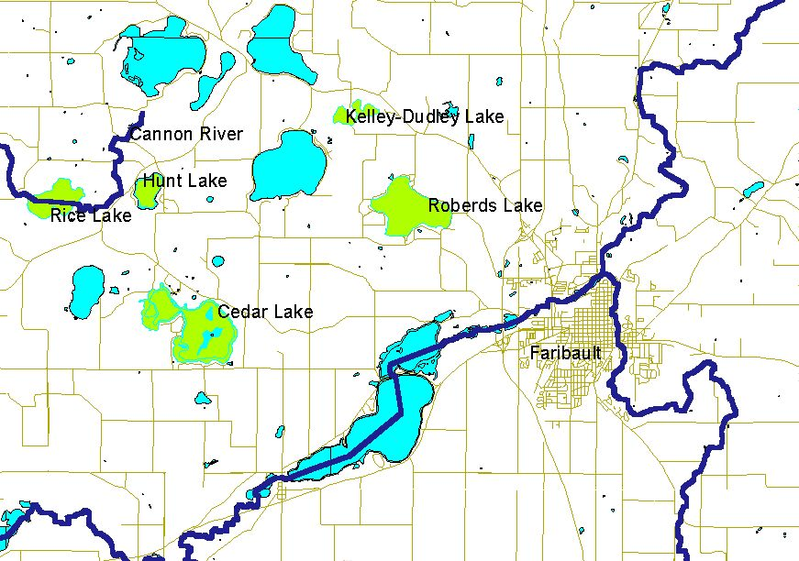
Figure 1. GIS Map of the five lakes studied and the surrounding area. Data from GIS database, Carleton College, Northfield, Minnesota.
Procedure:
Over an eight-week period we traveled to each of these lakes three to four times, first locating it on a GPS and then performing several tests on site. Cedar, Hunt, and Rice Lakes were sampled on April 22, May 9, and May 13; Kelly-Dudley and Roberds Lakes were sampled on April 15, April 22, May 5, and May 13. Color, conductivity, temperature, salinity, and turbidity were measured. We also collected a sample of the water in plastic bottles for later lab analysis. To be consistent we measured at what depth we tested these things and tried to keep the test site constant. To measure color, we examined the lake close to us and far away, noting the effects of vegetation and sediment in altering its color from clear to green or brown or any mixture in between. In measuring for conductivity, salinity, and temperature, we used the Yellow Spring Instruments, Incorporated, Model 85 (YSI). The sensing rod, which when placed in the water, calculates a variety of information. Conductivity can be described as the measurement, based on lake temperature, of mineral content and elements in a sample of water. Turbidity is the measurement of a particular lake’s murkiness, i.e. how much organic matter and sediment is suspended in the lake and how much light can get through. The turbidity of a lake is important because this murkiness inhibits sunlight penetration of the water surface and thus the growth of plants underneath, contributing to a less healthy lake habitat. We measured turbidity with a transparency tube, which is filled with water and then drained out the bottom until the black and white symbol at the bottom of the tube becomes visible. Once the disk is visible, the height of the water in the tube is recorded, and this is now the calculated murkiness of the water. Temperature is measured in Celsius, and Salinity (salt content) is found in parts-per-thousand or ppt.
We looked around at the landscape and gathered additional information regarding the status of the lake and its surrounding area. This includes wildlife sightings, human interaction, litter in or around the lakes, boats docked or out on the water, and land use. Using the Ion Chromatograph, we analyzed the respective water samples for several anions, including Chloride, Nitrite, Nitrate, Fluoride, Bromide, Phosphate, and Sulfate in order to judge the lakes’ overall health and element content.
Results:
Overall, the color for each lake was consistent, as far as we could tell (our measurement may have been influenced by atmospheric conditions or our own individual perceptions). Cedar, Hunt, and Rice maintained a murky greenish brown color, and Kelly-Dudley and Roberds appeared clear.
The conductivity of the lakes was also fairly stable (see Figure 2).
The salinity of each lake measured 0.1 ppt every sampling day with one exception: Roberds Lake showed a salinity value of 0.2 on April 22, which we believe to have been an error because the samples on the following sample days measured the usual 0.1 ppt.
The trends in the turbidity data varied by lake (see Figure 3). The turbidity of Cedar Lake increased over time. Kelly-Dudley and Roberds Lakes remained clear. Hunt and Rice Lakes showed a decrease and then an increase in turbidity over the sampling period.
The lakes show a rise in temperature over the eight-week period, although the temperatures of Kelly-Dudley and Roberds Lakes decreased quite a bit on May 5 (see Figure 4). We think this may be due to heavy rainfall (.96 inches) on the night of May 4 (see Figure 9); however, we have no way to determine this.
The chloride levels in the lake fluctuated over time, but usually less than 1 ppm, which is within reasonable error (see Figure 5). We saw the same kind of trend in the results for fluoride (Figure 6), sulfate (Figure 7), and nitrate (Figure 8).

The Ion Chromatograph found no traces of bromide or phosphate in our water samples and yielded only one result of nitrite. On April 22nd, Cedar Lake showed a nitrite level of 0.99 mg/L, which we believe to be an error, since the two subsequent samples yielded no nitrite.
Our observations of the surrounding lakes also gave us an idea of the wildlife that frequent the lakes. Most of the lakes had signs that indicated the types of fish that could be found. These included bass, walleye, northern pike, sunnies, crappies, and carp. Bird sightings included loons, herons, white pelicans, redwing blackbirds, Canadian geese, and ducks. Other wildlife included dragonflies, frogs, and turtles. Additionally we saw many signs of human life – houses, boats and boat ramps, oil on the water, and litter on the shore.
The daily rainfall over the sampling period (Figure 9) may also be useful.
GIS data also yielded information about the land use in the watershed areas around our lakes. (These data were obtained from the Minnesota Department of Natural Resources Data Deli.) Cedar Lake has streams flowing through, cultivated land, rural residential complexes, other rural development, deciduous forests, wetlands, grasslands, and islands containing mostly deciduous forest, with some grassland. Hunt Lake has farmsteads, rural residential development complexes, cultivated land, grasslands, deciduous forests, a stream nearby, and some wetland. The Cannon River flows directly through this section, but is not near the lake. Kelley-Dudley Lake has major wetland areas, grassland, deciduous forest, rural residential complexes, cultivated land, and gravel pits near the wetlands. Rice Lake has farmsteads, cultivated land, grassland, deciduous forest, streams flowing through, the Cannon River flowing through, and wetlands. Roberds Lake has streams flowing through, deciduous forests, grasslands, farmsteads, wetlands, cultivated land, and rural residential complexes.
Discussion:
We sampled our lakes at only one site at each lake and for only two months. To get an idea of how typical our results were, we compared them with the results of an earlier 1999 study conducted by the Minnesota Pollution Control Agency (Heiskary, 2000). Their study did not include Hunt or Rice Lakes, but we have comparison data for Cedar, Roberds, and Kelley-Dudley Lakes. The chloride levels we measured were typical: both our measurements and the 1999 measurements showed chloride levels hovering between 10 and 14 mg/L, for the three lakes (Heiskary, 2000). Hunt and Rice Lakes were respectively slightly above and below this range. The 1999 study reported an average conductivity of 290 mg/L for Roberds Lake, making our conductivity measurements (238-275 mg/L) somewhat, but not substantially, below average. In contrast, our conductivity measurements for Cedar and Kelley-Dudley Lakes were somewhat above the 1999 averages (250 and 250-260 mg/L respectively).
We also compared our anion results to water quality standards prescribed by the Environmental Protection Agency, specifically the Minnesota Pollution Control Agency. The levels we measured in our study were well below the acceptable standards for all lake uses. These uses include aesthetic enjoyment and navigation, domestic consumption (drinking water), industrial consumption, agricultural irrigation, and agricultural livestock and wildlife use. For chloride, the standards given are 250 mg/L for domestic consumption, and 50 –100 mg/L for industrial consumption. The maximum chloride level we found was 16.25 mg/L in Hunt Lake on May 9. For fluoride, the standard given is 2-4 mg/L for domestic consumption. The maximum fluoride level we found was 0.16 mg/L in Roberds Lake on May 13. For nitrate as N, the standard given is 10 mg/L for domestic consumption. The maximum nitrate level we found was 0.59 mg/L in Hunt Lake on May 9. For sulfate, the standard given is 250 mg/L for domestic consumption. The maximum sulfate level we found was 19.99 mg/L in Hunt Lake on May 9 (MPCA, 2003).
While the changes in anion levels were slight (a few parts per million at most), we believe these changes may have been caused by rainfall washing them into the lakes through streams or groundwater leaching, since the changes occurred after rainstorms. However, the changes in anion levels may also be attributed to error but are within acceptable error standards.
Our data has lead us to conclude that the water quality of these lakes is good, however, this conclusion conflicts with the earlier 1999 study, most specifically in the case of Roberds Lake. The authors of the study deemed the lake unhealthy due to their study of phosphorus levels, lake temperature at different depths, and oxygen content (Heiskary, 2000). Since our study did not include these measurements, we suggest that future tests should be done to determine if the data is the same or has changed in the past four years.
The size of a lake’s watershed and the land-use patterns within that watershed are major factors affecting water quality. The 1999 study theorized that the ratio of watershed area to lake area would affect the load of phosphates and other nutrients that would runoff into the lake (Heiskary, 2000). None of our lakes have particularly large ratios, although the Roberds Lake ratio is medium-sized. Under this theory, the relatively small ratios may contribute to the relative cleanliness of these lakes. The theory does not gain any additional support from our data, but may prove useful in comparing our lakes with other lakes in the region.
The land-use patterns are also likely to contribute to water cleanliness. Most of the cultivated land near our lakes is separated from them by other features such as forests and grasslands, probably limiting its effect on the lakes, whereas other bodies of water have farmland right up to the edge of their banks, increasing the effects of runoff. Rural development also exists around all of our lakes, but is generally not extensive and probably has a limited effect. Grasslands and forests may also play a role in protecting the lakes. One feature that particularly jumped out at us was a line of gravel mines above the wetlands near Kelley-Dudley Lake. It would be prudent to conduct a study to find out if and how the mines affect the wetlands and how the wetlands affect the lake.

Conclusion:
From what we know about the variables we measured we have concluded that all five lakes are clean. In particular, our results in comparison to water quality standards are remarkable. The comparisons between our measurements and the 1999 measurements lead us to believe that chloride levels in our lakes have been fairly constant over the past few years and that conductivity has a range of normal variation over the course of a year. There are many other measurements that the 1999 study took that we did not take and vice versa; it would be useful for future studies to be more comprehensive (particularly with measures such as total phosphorous, ph, and dissolved oxygen).

Acknowledgements:
We’d like to thank for all their help and support: Professor Haileab, Liz Clark, Heather Hilchey, Melissa Keevil (for her companionship, instruction, and navigational skills), the Geology Department, Professor Savina, and the surrounding lake and stream groups. Without their knowledge and time, we could not have mastered GIS, Adobe Illustrator, or any other key parts that made this paper possible.

References:
Heiskary, Steve. April 2000. “Status and Trend Monitoring Summary for Rice County,
Minnesota 1999 (Lakes: Cannon, Wells, Kelly, Dudley, Circle, Cedar, and Roberds).” Done by Minnesota Pollution Control Agency: Environmental Outcomes Division, Environmental Monitoring and Analysis Section. 3-37.
Minnesota Department of Natural Resources Data Deli. 1999. http://deli.dnr.state.mn.us/
Minnesota Pollution Control Agency. 12 February 2003. “Waters of the State: Chapter
7050.0220, Specific Standards of Quality and Purity by Associated Use of Classes.” http://www.revisor.leg.state.mn.us/arule/7050/0220.html. Found 14 May 2003.

Water Quality in Union, Circle and Fox Lakes:
Rice County, Minnesota
Spring 2003

Rebecca Farley
Annaka Larson
Sead Puskar
Sarala Puthuval
Introduction
The purpose of this project is to assess the water quality of Union Lake, Circle Lake, and Fox Lake. In recent decades, water quality in these lakes has been poor, with low oxygen and high nutrient levels (Minnesota Department of Natural Resources (DNR); Heiskary 1999). This project will evaluate the changes in water quality and add to the data collected by others in the past in case there is a future effort to reduce water contamination. Five times during April and May 2003 we measured dissolved oxygen, turbidity, conductivity, salinity, dissolved anions, and temperature. In analysis we looked mainly at anion concentrations and turbidity to determine whether runoff from the watersheds might be bringing nutrients to the lakes and whether this was causing algae to grow.

Rice County geography
Rice County in southeastern Minnesota covers two ecological regions. The eastern half (east of Interstate 35) is in the Western Cornbelt Plains, while the western half is in the North Central Hardwood Forest (lakeaccess.org; Heiskary and Wilson 1989). Historical ecosystems aside, land use in all of Rice County is mostly agricultural, including cultivation of corn and soybeans as well as raising of turkeys and other fowl, cattle, and hogs. There are some small towns and some country houses.
Because of growth and sprawl in the area surrounding Minneapolis and Saint Paul, Rice County is very close to the leading edge of urbanization. Local towns such as Northfield, Dundas, and Faribault are also growing. At the moment, water runoff problems are primarily caused by agricultural chemicals and septic tanks, and are exacerbated by tiling and lack of wetlands (lakeaccess.org, B. Haileab).
The rocks under Rice County are composed of limestone nearest the surface; below that some layers are sandstone aquifers. There are regions of karst topography. The surface is rolling, shallow hills shaped by glaciation. West of I-35 there is a cluster of glacial lakes (Wright 1989), including the ones we studied (see map, figure 1.)

Methods
We tested water at two sites on Union Lake, two sites on Circle Lake, and one site on Fox Lake. We took samples between 1:00 and 3:00 pm on five afternoons in April and May. The secondary sites at Union and Circle lakes were only visited twice.
Samples were taken in shallow water from the shore or from docks. At each site we used a Yellow Springs Instruments model 85 instrument to measure temperature, conductivity, salinity, and dissolved oxygen. We also took water samples, measured turbidity using a Secchi tube, and took notes on the color and appearance of the lakes. On some days we took rough depth measurements using the Secchi tube and pH measurements using a VWR electronic pH meter.
In the laboratory, water samples were run through an ion chromatograph to test for the presence of fluoride, chloride, nitrate, nitrite, bromide, phosphate, and sulfate.

Results

Table 1A
Union Lake A | Units | 4/8/2003 | 4/15/2003 | 4/17/2003 | 4/24/2003 | 4/26/2003 | 5/8/2003 | 5/15/2003
Fluoride (ppm) | ppm | 0.0750 | 0.0000 | 0.0000 | 0.0000 | 0.1021 | 0.0000 | 0.0000
Chloride | ppm | 25.0277 | 14.6538 | 26.2769 | 24.1092 | 25.3227 | 25.2861 | 21.5675
Nitrite | ppm | 0.0000 | 0.0000 | 0.0000 | 0.0000 | 0.0000 |  | 0.2353
Nitrate | ppm | 1.2808 | 0.0000 | 0.4368 | 2.6429 | 2.4518 | 1.7486 | 3.8679
Sulfate | ppm | 23.5885 | 3.6136 | 23.6702 | 23.7542 | 26.6273 | 24.1101 | 20.4723
Temperature | °C | (no data) | (no data) | 11.2 | 12.0 | 16.1 | 15.1 | 14.7
Dissolved oxygen | % |  |  | 77.0 | 67.7 | 65.0 | 99.3 | 92.7
Dissolved oxygen | ppm |  |  | 8.70 | 7.27 | 7.66 | 10.17 | 8.68
pH |  |  |  |  | 9.4 | 7.47
Salinity | ppt |  |  | 0.2 | 0.2 | 0.2 | 0.2 | 0.2
Conductivity | micro s |  |  | 309.3 | 332.2 | 375.6 | 376.2 | 337.3
(unadjusted)
Conductivity | micro s |  |  | 421.1 | 439.8 | 452.6 | 463.1 | 421.5
(adjusted)
Secchi Depth | cm |  |  | 84.5 | >120 | >120 | >120 | >120
Depth | cm |  |  |  |  | 84.500
Color |  |  |  | brown | yellow |  | clear | yellow
Comments |  |  |  | rain 4/16 |  |  | rain 5/4-5/5 | water level
 |  |  |  | weather: cold, |  |  | depth lower | much higher
 |  |  |  | cloudy skies
(adjusted)
Secchi Depth | cm |  |  |  |  |  |  | 87.6
Depth | m |  |  | 1.016
Color |  |  |  |  | yellow
Comments |  |  |  |  |  |  |  | water higher

Table 1B
Union Lake B | Units | 4/8/2003 | 4/15/2003 | 4/17/2003 | 4/24/2003 | 4/27/2003 | 5/8/2003 | 5/15/2003
Fluoride (ppm) | ppm | no data | no data | 0.0000 | 0.0000 | no data | no data | 0.0000
Chloride | ppm | available | available | 25.4095 | 25.9088 | available | available | 17.9310
Nitrite | ppm |  |  | 0.0000 | 0.1932 |  |  | 0.0000
Nitrate | ppm |  |  | 0.2661 | 2.3630 |  |  | 2.7585
Sulfate | ppm |  |  | 23.3969 | 25.5931 |  |  | 19.4813
Temperature | °C |  |  | 10.4 | 13.0 |  |  | 17.0
Dissolved oxygen | % |  |  | 77.9 | 62.0 |  |  | 59.0
Dissolved oxygen | ppm |  |  | 8.85 | 7.78 |  |  | 5.90
pH |  |  |  |  | 7.6
Salinity | ppt |  |  | 0.2 | 0.2 |  |  | 0.2
Conductivity | micro s |  |  | 299.9 | 332.8 |  |  | 328.5
(unadjusted)
Conductivity | micro s |  |  | 416.0 | 430.5 |  |  | 390.3
(adjusted)
Secchi Depth | cm |  |  |  |  |  |  | 87.6
Depth | m |  |  | 1.016
Color |  |  |  |  | yellow
Comments |  |  |  |  |  |  |  | water higher

Table 2A
Circle Lake A | Units | 04/17/2003 | 04/24/2003 | 04/27/2003 | 05/08/2003 | 05/15/2003
Fluoride (ppm) | ppm | 0.0706 | 0.0000 | 0.0934 | 0.0000 | 0.0000
Chloride | ppm | 12.1301 | 12.6280 | 12.4322 | 12.3666 | 10.1119
Nitrate | ppm | 0.9039 | 0.0000 | 0.0000 | 0.0000 | 16.0100
Sulfate | ppm | 14.1925 | 12.8270 | 13.4799 | 21.1538 | 50.1900
Temperature (in C) | °C | 7.8 | 14.8 | 18.2 | 18.0 | 17.2
Dissolved oxygen | % | 70.0 | 92.0 | 72.4 | 106.8 | 80.0
Dissolved oxygen | ppm | 6.40 | 10.60 | 12.85 | 9.84 | 9.84
pH |  |  | 8.98 | 8.97
Salinity | ppt | 0.2 | 0.2 | 0.2 | 0.2 | 0.1
Conductivity (unadjusted) | micro s | 244.0 | 252.7 | 286.0 | 311.6 | 264.1
Conductivity (adjusted) | micro s | 361.0 | 314.1 | 328.6 | 359.9 | 310.6
Depth | m | 0.6 |  | 0.63 | 0.65
Color |  | dark brown | brown | yellow | murky
Secchi depth | cm | 16.9 | 25.0 | 35.0 | 23.0 | 26.1
Additional comments |  | rain 4/16 | rained 4/18 | no rain, no snow | rain 5/4, 5/5
 |  | no snow | no snow | new plant life | dead plant matter
 |  | weather: cold, cloudy | very windy | plant stalks in water | on bottom
 |  | skies, slightly windy | fields ploughed | drifted around pier
 |  |  | grass floating in | lots of fish jumping
 |  |  | water | swifts, boaters

Table 2B
Circle Lake B | Units | 04/17/2003 | 04/24/2003 | 04/27/2003 | 05/08/2003 | 05/15/2003
Fluoride (ppm) | ppm | no data available | 0.0000 | no data available | no data available | 0.2409
Chloride | ppm |  | 10.8486 |  |  | 11.5541
Nitrate | ppm |  | 0.0000 |  |  | 1.8273
Sulfate | ppm |  | 19.4373 |  |  | 20.4144
Temperature (in C) | °C |  | 12.3 |  |  | 14.5
Dissolved oxygen | % |  | 95.5 |  |  | 66
Dissolved oxygen | ppm |  | 10.25 |  |  | 6.71
pH |  |  | 12.3
Salinity | ppt |  | 0.1 |  |  | 0.2
Conductivity (unadjusted) | micro s |  | 231.3 |  |  | 265.7
Conductivity (adjusted) | micro s |  | 303.9 |  |  | 331.2
Depth | m
Color |  |  | tan |  |  | brown/green
Secchi depth | cm |  | 25.0 |  |  | 39.8
Additional comments |  |  | Less windy

Table 3
Fox Lake | Units | 4/17/2003 | 4/24/2003 | 4/26/2003 | 5/8/2003 | 5/15/2003
Fluoride | mg/L | 0.1025 | 0.1006 | 0.0888 | 0.0841 | 0.2409
Chloride | mg/L | 10.7496 | 10.9072 | 10.6831 | 11.1681 | 11.5541
Nitrate | mg/L | 3.552 | 3.9779 | 3.6431 | 4.7309 | 1.8273
Sulfate | mg/L | 17.3812 | 17.7816 | 17.1411 | 18.6563 | 20.4144
Temperature | °C | 9.4 | 11.3 | 12.4 | 14.3 | 16.0
Dissolved Oxygen | % | 82.8 | 83.5 | 72.4 | 90.7 | 77.6
Dissolved Oxygen | mg/L | 9.20 | 9.15 | 7.81 | 9.06 | 7.42
pH |  |  | 8.31 | 8.42
Salinity | ppt | 0.2 | 0.2 | 0.2 | 0.2 | 0.2
Conductivity (unadjusted) | micro s | 227.1 | 251.9 | 246.7 | 275.3 | 290.1
Conductivity (adjusted) | micro s | 323.4 | 341.2 | 319 | 347.9 | 350.2
Secchi depth | cm | > 120 | > 120 | > 120 | > 120 | >120
Depth | m | 0.7
Color |  | clear | yellow | greenish yellow | yellowish clear | murky
Additional comments |  | rain 4/16 | rain 4/18 | no rain or snow |  | rain 5/10
 |  | no snow | no snow, windy | heron, small live fish |  | slightly higher
 |  | weather: cold, cloudy, | fields ploughed | 1 large dead fish |  | depth
 |  | slightly windy | grass floating | brown chunks
 |  |  | in water | boaters
 |  |  | heron, coots | herd of cattle next
 |  |  | brown floating | to lake
 |  |  | clumps

Discussion

General Findings

Some trends were common to all the lakes. The ion chromatograph detected only fluoride, chloride, nitrate, nitrite, and sulfate, never bromide or phosphate. Chloride and sulfate were the only ions consistently present at all lakes. The average depth at each of the testing sites varied, but all sites were somewhat flooded on May 15, because of heavy rain the day before. We estimate that Union Lake rose 20-30 cm.

Some of the measurements we took are more relevant to our study than others. The most important ions are nitrate and nitrite, because they come from fertilizer and feed algae. Conductivity, which reflects the total dissolved ions, is also relevant. Secchi depth is an important measure of algal growth, because turbidity in lakes is usually caused by algal biomass. Our Secchi measurements, though useful, are limited because they were taken with a 1.2-meter-long cylinder, which was too short to record any variation in Union or Fox Lake. A Secchi depth of 3 meters is the minimum for good water (lake grading system by Dick Osgood and John Barten, lakeaccess.org,) so we do not know how close those lakes came to this (see Tables 1, 2, 3, 7 for Secchi depths.)

Data from the B sites (Table 1B, 2B) do not appear in our graphs because they are very similar to A site data. Salinity, pH, and unadjusted conductivity were also judged not relevant.

Ion chromatograph
Figure 2 Figure 3
Figure 4 Figure 5

Figure 6
Nitrite Content in All Lakes
0.00
0.05
0.10
0.15
0.20
0.25
4/8/03
4/15/03
4/22/03
4/29/03
5/6/03
5/13/03
Date
ppm
Union Lake
Circle Lake
Fox Lake

Union Lake (see table 1A, 1B)
Union Lake is just west of Interstate 35. We took water samples from two sites, one at the northeast end (A) and one at the south end (B). Union Lake is near I-35, Highway 3, and Bagley Avenue.

Table 4: Water temperature and conductivity in Union Lake
Date | April 17 | April 24 | April 26 | May 8 | May 15
Temp. (ºC) | 11.2 | 12.0 | 16.1 | 15.1 | 14.7
Conductivity (μS) | 421.1 | 439.8 | 452.6 | 463.1 | 421.5

The temperature of Union Lake generally rose over the course of the term. The conductivity remained fairly constant. Because our Secchi tube was short, we cannot determine whether there was a change in turbidity (see table 7). Nitrate levels (figure 4), which were below 4 mg/L throughout, were somewhat correlated with rainfall (see figure X) and perhaps with sulfate levels (figure 6). Nitrite showed up only twice, once at the A site and once at the B site (table 1A, 1B), in amounts less than 0.1 mg/L. The maximum level for nitrate in drinking water for the state of Minnesota is 10 mg/L and for nitrite is 1 mg/L, so in that respect Union Lake does not have too many nitrogen ions; we do not have information about other standards.

The chloride in Union Lake fluctuated between about 21 and 26 mg/L. There was no apparent trend in the chloride levels (see figure 3.)

Circle Lake (see table 2A, 2B)
Circle Lake is south of Union Lake and farther west of the interstate. Here we took samples from the north shore (A) at a public lake access site with a boat launch and from the east shore (B) on the property of Circle Lake Area Sales and Service on 124th street.

Table 5: Water temperature and conductivity in Circle Lake
Date | April 17 | April 24 | April 26 | May 8 | May 15
Temp. (ºC) | 7.8 | 14.8 | 18.2 | 18.0 | 17.2
Conductivity (μS) | 361.0 | 314.1 | 328.6 | 359.9 | 310.6

Overall, Circle Lake warmed by about 10ºC; conductivity was stable. Our Secchi tube was able to give us precise readings of turbidity at Circle Lake, because all the readings are 35 centimeters or below. Our subjective observations of the color of the water describe it at various times as ‘brown,’ ‘yellow,’ or ‘murky,’ affirming our conclusion that the water is more turbid at Circle Lake than at our other two testing sites.
Chloride levels stayed fairly consistent except for a drop of about 2 mg/L on the last day. This change could be due to the rainfall on May 11th diluting the water.
It is hard to correlate anion levels with rainfall; most of the time they change very little after rain, except after the rain on May 11th when nitrate, nitrite, and sulfate levels shoot up (see figures 4, 5, 6, 7.) We infer that fertilizers were applied in the vicinity of Circle Lake sometime between May 8th and May 11th, which would thus account for the sudden rise in concentration of these chemicals in the lake due to surface runoff.

Fox Lake (see table 3)
Fox Lake, the smallest, is just south of Circle Lake; the two lakes are connected by Wolf Creek. Again, the sample site was a public access fishing dock and boat launch.

Table 6: Water temperature and conductivity in Fox Lake
Date | April 17 | April 24 | April 26 | May 8 | May 15
Temp. (ºC) | 9.4 | 11.3 | 12.4 | 14.3 | 16.0
Conductivity (μS) | 323.4 | 341.2 | 319.0 | 347.9 | 350.2

Like Union and Circle lakes, Fox lake got warmer and its conductivity stayed the same. The Secchi readings at Fox Lake were greater than 1.2 meters every time, so we cannot determine whether there was a change in turbidity over the course of the project. Fox Lake certainly appeared to be the clearest of the lakes; we recorded observations of the color as “clear” and “yellowish” almost every time. However, a more extensive study of Secchi depths would be needed in order to understand how the turbidity of Fox Lake affects its water quality. Fox Lake also has brown chunks of algae-like matter floating in it all the time.
A study of the ions in the water reveals that there was significantly more fluoride in Fox Lake than in Circle Lake or Union Lake, with levels varying in no clear pattern from 0.0841 parts per million to 0.2409. The chloride levels in Fox Lake remained steady, with a maximum variation of 0.871 parts per million. From this we can determine that there was no significant change in the factors that affect chloride levels in the lake. Nitrate and sulfate levels were fairly stable throughout the study, with a sharp drop in nitrate and a small rise in sulfate on the last day of sampling. Further sampling would be necessary to determine if these changes are an anomaly or if they reflect a new trend in the levels of these ions in the lake.

Comparison
In comparing the lakes to one another, we found some similarities, due in great part to their proximity and thus similar bedrock, local land use, and weather. All the lakes had a salinity that stayed constantly at 0.2 parts per thousand. The temperatures of each lake increased, in general, over time, reflecting the warming of air temperatures as the season progressed.
Definite differences between the lakes exist, however. Fox Lake was the coldest of the three lakes, with a median temperature of 12.4° Celsius, then Union with a median temperature of 14.7° Celsius, and Circle Lake was the warmest with a median temperature of 17.2 ° Celsius. Since temperature is inversely related to dissolved oxygen content, we infer that Fox Lake would have the greatest dissolved oxygen content, and Circle Lake the least. Conductivity hovered between 300 and 400 microsimmons at Fox and Circle Lakes, but between 400 and 500 at Union Lake. Since conductivity is related to salinity and ions in the water, and since the salinity of all three lakes was the same, there must have been more ions at Union Lake to account for the difference.

Table 7: Comparing Secchi depth (in meters)
Date | April 17 | April 24 | April 26 | May 8 | May 15
Union | 0.85 | >1.2 | >1.2 | >1.2 | >1.2
Circle | 0.17 | 0.25 | 0.35 | 0.23 | 0.26
Fox | >1.2 | >1.2 | >1.2 | >1.2 | >1.2

Clearly Circle Lake is the most turbid of the three. We cannot determine whether Fox or Union is the clearer lake because our Secchi tube was not long enough to give us precise readings at those lakes. From our observations of the lake clarity, however, we believe that Fox is the clearer lake, but we do not have data to support this conclusion.
The fluoride levels remained fairly constant in each of the lakes; they were generally absent or present only in small amounts. However, Fox Lake did have significantly more fluoride than Circle or Union Lakes. Fluoride levels at Fox Lake varied from 0.0841 parts per million to 0.2409 parts per million; at Circle Lake the highest level was 0.0934 parts per million and at Union Lake the highest measurement was 0.1021 parts per million. This may be due to slight differences in bedrock or to differences in the rock the groundwater seeps through as it travels to Fox Lake. The chloride levels were clearly the highest in Union lake, consistently in the lower 20s ppm. The chloride in Circle appeared to be higher than in Fox, but contrary to the to opinion of the man we met at Fox Lake, the difference in chloride levels was slight. The difference in chloride levels could be due to the pattern of roads, and thus distribution of road salts, in the surrounding area. Both sulfate and nitrates remained at relatively low levels in Fox and Union Lakes during our study, while at Circle Lake they went from nonexistent to more than 16 ppm for nitrate and 50 ppm for sulfate. This could be due to a sudden influx of fertilizers from farms or sewage from faulty septic tanks on Circle Lake, while wastes of these types may have been better managed at Fox and Union lakes. We know from the man on the Circle Lake Association that fecal material has been present in the lake in the past.

Sources of Uncertainty
Our measurements of dissolved oxygen were wholly unreliable; this is due to the variability of the YSI meter and the fact that we were unable to calibrate the machine each time we went to the field. The dissolved oxygen measurements were not in accordance with the usual dissolved oxygen readings for lakes, so therefore we will discard them in our discussion of the water quality. Since temperature and dissolved oxygen are indirectly related, we can infer that the dissolved oxygen content of each lake varies inversely with the temperature, but this assumption is not based on empirical facts and can only be used to study the lakes comparatively. Our turbidity measurements are useful only to a certain extent, as our Secchi tube only measured clarity up to 120 centimeters. The turbidity measurements at Circle Lake always fell within the range of measurable turbidity, but at Fox and Union Lakes, it was at times greater than 120 centimeters. Therefore, our data for those sites is imprecise. In order to have precisely measured the turbidity, we would have had to take a boat into the middle of the lake where the water was the deepest and use a Secchi disk on a rope to take the measurements.

Broader issues of water quality in the lakes
Lake eutrophication
All three lakes have been classified by the state department of natural resources as eutrophic or hypereutrophic (http://www.dnr.state.mn.us.) Our data did not support this, perhaps because it was taken in the spring before algal growth begins. Personal communications from local observers (Circle Lake Assoc. member, Fox Lake resident, B. Haileab) tell us that these lakes do indeed develop scums of algae in summer. In addition, these observers mentioned the occurrence of fish kills and the occasional presence of feces in the water after a large rainfall.

Other Information that would be Useful
Our study of water quality in the lakes suffered severely from our lack of accurate information on dissolved oxygen. In order to correctly measure dissolved oxygen, we would have needed to spend an extensive amount of time at each site calibrating the YSI meter in order to record accurate measurements. Unfortunately, we were not aware of the deficiencies in the meter until we had already completed our water sampling. Dissolved oxygen is one of the most important indicators of water quality and so would have been useful for our study. More accurate Secchi readings would have been helpful as well. They would have enabled us to learn the amount of suspended particles in the water such as silt, clay, organic and inorganic matter, and microscopic organisms. Suspended particles have a great impact on the light penetration of the water, which in turn affects the life that can survive in the lake. Knowing the concentration of suspended particles would have helped us asses the health of the lakes as well.
It would also have been useful to know more about the activities of the farmers who live in the vicinity of the lakes. Had we known when they were fertilizing their land and what measures they were taking to prevent runoff water contamination, we might have been able to enhance our understanding of our results and learn more about the true extent of water contamination.
Comprehensive results of water testing at the lakes in past years would have been useful as well. We were able to obtain records of some other testing, but some of these results were from the summer, which are not necessarily applicable to our spring data.

Conclusion
Although we found many sources of uncertainty in our data, we believe that there are distinct differences between Circle, Fox, and Union lakes, despite their proximity to each other. Because it is the coldest, and we believe it to be the clearest, we have determined that Fox Lake is the healthiest of the three. Union Lake is warmer, but still quite clear. Circle Lake appears to be the least healthy of the three, because of its high temperature and the large amount of nitrate and sulfate present.
The main water quality event we were testing for was change in nitrogen ion levels. During our study, the levels for the most part did not exhibit a clear pattern of increase or decrease. Circle Lake showed an upward trend, but as it appeared near the end of the study we would have needed to continue sampling to be more certain.
Lakes are affected by a multitude of factors, but our findings lead us to suggest that more should be done, especially at Circle Lake, to prevent fertilizers and fecal material from entering the lakes.
Unfortunately, we cannot effectively compare the current health of these lakes with information from the past because much of the data we had available to us from previous Carleton studies was from summer, when organic composition of the lakes is quite different; we cannot accurately compare the lakes in spring this year with the lakes in late summer in years past because there are simply too many differing variables.

Acknowledgements
We have been aided by many people during the course of this project, and we would like to thank Liz Clark, Bereket Haileab, the Carleton Geology Department, the lakeside residents who offered their stories to us, our Environmental Geology colleagues, and William Wischstadt.

References
Circle Lake Association member. Personal communication. April 24, 2003.
Fox Lake resident. Personal communication. May 15, 2003.
Minnesota Department of Natural Resources, http://www.dnr.state.mn.us
Haileab, B. Personal communication. April and May, 2003.
Heiskary, Steve, Minnesota Pollution Control Agency. “Status and trend monitoring summary for Rice County, Minnesota, 1999. (Lakes: Cannon, Wells, Kelly , Dudley, Circle, Cedar, and Roberds.” at http://www.pca.state.mn.us/water/pubs/lar-riceco99.pdf
Heiskary, Steven and Wilson, C. Bruce. “The regional nature of lake water quality across Minnesota: An analysis for improving resource management.” Journal of the Minnesota Academy of Science Vol. 55, No. 1, 1989, pp. 71-77.
http://lakeaccess.org/
Ecoregion map at http://lakeaccess.org/ecology/lakeecologyprim17.html
Lake grade system at http://lakeaccess.org/lakedata/datainfograde.html
Wright, H. E. "Origin and Developmental History of Minnesota Lakes." Journal of the Minnesota Academy of Science Vol. 55, No. 1, pp. 26-31.

Tiles: Impact on Streams

Carolynn Johnson
Heather Pavlak
Hilde Schmitt
Damian Winters

Environmental Geology
May 2003

Introduction:
Drainage tiles are used in wetland areas too saturated for efficient farming. Modern tiles are usually plastic tubes with small openings, buried about three or four feet underground. They provide a route for the water to flow out of the field with less resistance than the soil, so the water flows more quickly. They lower the water table to improve root development, and cause the ground to dry out more quickly after heavy rains and thaw earlier in the spring.
The purpose of this project is to monitor the drainage tiles in Rice County (see figure 1) to determine the content and effects of the water that the farmlands put into the streams. We are monitoring two tiles that are draining active farmland, and one control tile that is no longer in use. The three major pollutants of agriculture nutrients and fertilizers are nitrogen, phosphorous and potassium (Ribaudo, 2000). Plants need nitrogen that they cannot get from the soil in order to grow, which can be found naturally in both animal manure and plant legumes which naturally convert chemicals in the soil into nitrogen. The most commonly used commercial fertilizer is anhydrous ammonia. Plants do not absorb all of the nutrients that are put on the soil. Therefore, since the nutrients are dissolvable, an estimated 4.2 million tons of nitrogen and 1 million tons of phosphorous runoff into water supplies every year in the United States (Clark, 1989). Nitrogen is the most easily dissolved nutrient and therefore is the most abundant in water supplies, followed by phosphorous and potassium.
These nutrients create problems in the water supplies. Because nutrients are made to promote plant growth, they create excessive algae and surface water plant growth, called eutrophication. As the algae and plants decompose, they create bacteria, which reduces the dissolved oxygen in the water. They also produce an unpleasant odor and taste, along with increasing the iron and manganese levels in the water, which affect the control of harmful coliform bacteria. The algae also becomes a problem in the water treatment process causing millions of dollars of damage to water filters each year by clogging them. Another negative effect of increased levels of nitrates is that they can cause methemoglobinemia, or “blue baby syndrome." Sometimes the algae growth can be beneficial by increasing dissolved oxygen levels, but only if there is a greater respiratory rate with the lakes’ vegetation than the rate of decomposing vegetation. In this project, we will present the study of three tiles and discuss their impact on the environment.
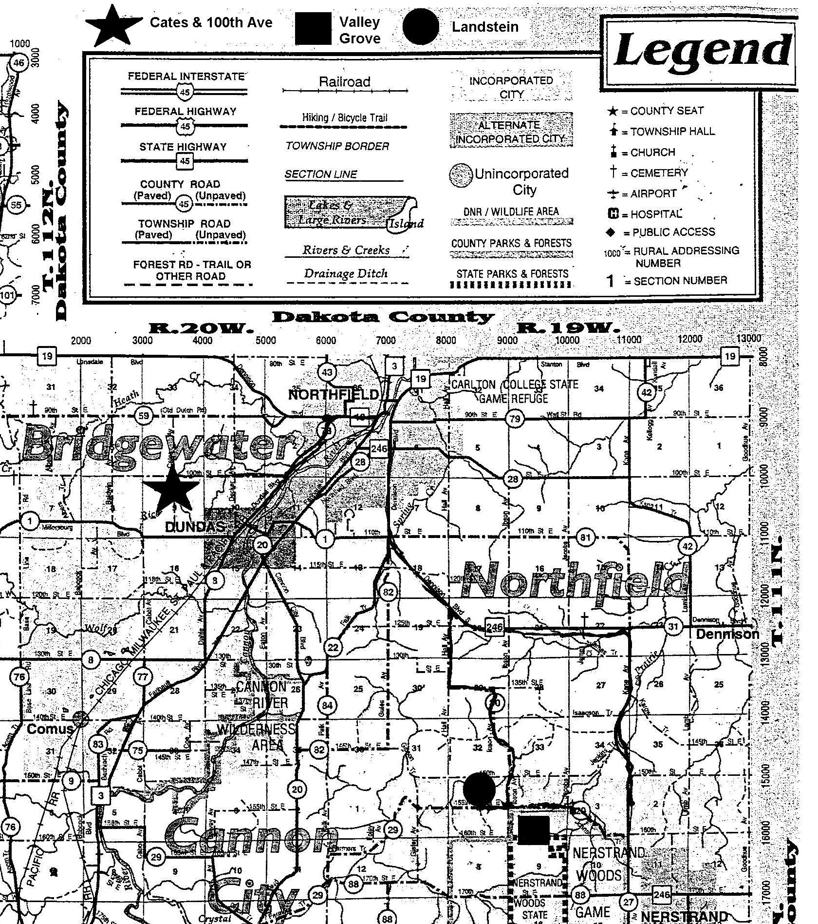
Figure 1: Map of Rice County including locations of tiles used for research
Figure 1: Map of Rice County and tile location sites.

Procedure:
The study took place from April 1, 2003 to May 13, 2003. There was approximately 3-4 inches of precipitation during this time (Figure 2). At all of the tiles we observed an increased flow of water after rain. 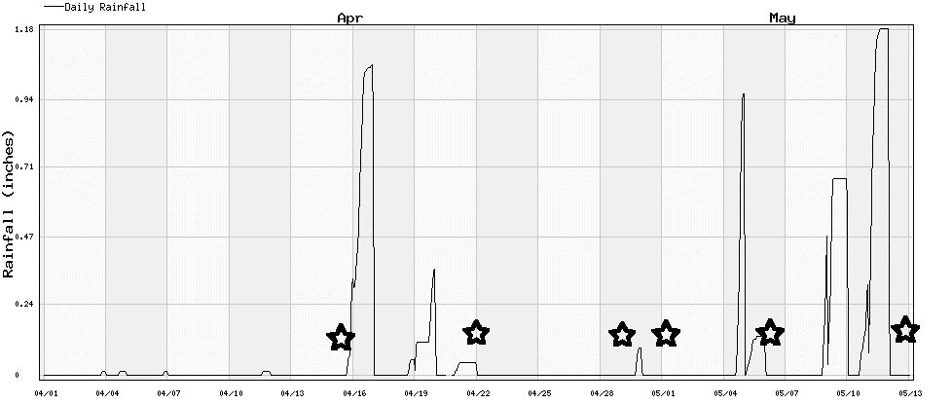
Figure 2: Amount of rainfall in Northfield, Minnesota for the testing period. The stars are the days in which the water samples were taken, and as the rainfall increased there was also visible increases in the amount of water flowing out of the tile.

The testing procedure was to go out to the field site with an YSI-85 meter (Yellow Springs Instrument, Incorporated, Model 85), secchi tube and testing bottle. We used the YSI meter and recorded the results, while testing for turbidity with the secchi tube. We then took a water sample and sent the water to the lab so that Bereket Haileab could test for seven elements: fluoride, chloride, nitrate, sulfate, nitrite, bromine, and phosphate, with the ion chromograph. Bromine, phosphate and nitrite did not show up in the results.
The first test site, referred to as Cates Avenue, was right next to Cates Avenue, approximately 250 feet south of 100 Street East. The GPS location is 15T0481601. The tile that we tested was draining water from active farmland. The water was flowing off the tile into Rice Creek. The farmland appeared barren and exposed, without any ground cover and only leftover stalks from the previous crops. As a buffer between the edge of the farmland and the stream, there was approximately 2-3 feet of native or natural grass.
The second site was referred to as Landstein, after the owner of the farm, and was approximately 100-150 feet north of 155th Street East and approximately 500 feet east of Ibson Avenue. The GPS location is 15T0489600. The tile was the old ceramic kind (see Figure 3) and was draining active farmland. We saw an area where new PVC tiling was being installed (see Figure 4). The farmland also was barren and had no visible signs of green vegetation. It appeared to have been plowed around April 8th. The stream and tile outlet were buffered with a dense covering of box elder and a few older and taller trees (see Figure 6). On the other side of the road, however, the invasive box elder had been removed and only the native taller trees were left standing which decreased the erosion of the land near the creek (see Figure 5). On the Landstein side, the farmer was losing a quarter of an acre of land because of drainage problems, and yet on the other side of the road the farmer was able to utilize it for cattle grazing.

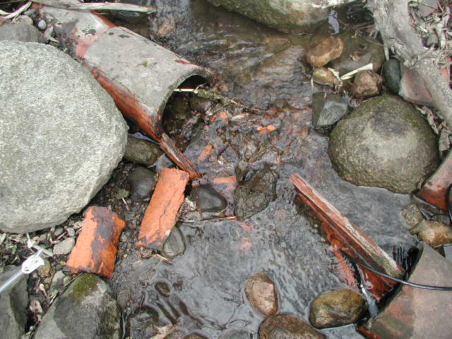
Figure 3 This is an example of ceramic tile still in use at the Landstein farm in Southern Minnesota. These ceramic tiles can be up to 100 years old. The tile in this photo has begun to erode and break apart.
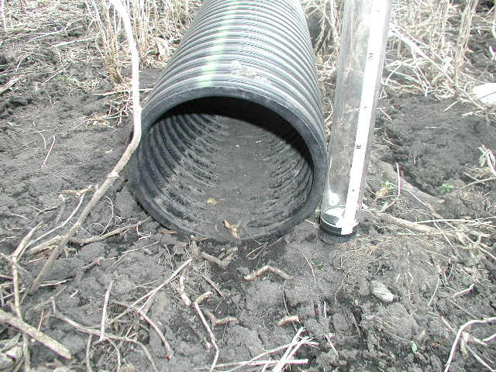
Figure 4 This is an example of the newer tile being put in today. This tile has a diameter of
approximately 20 cm and made of a type of plastic.

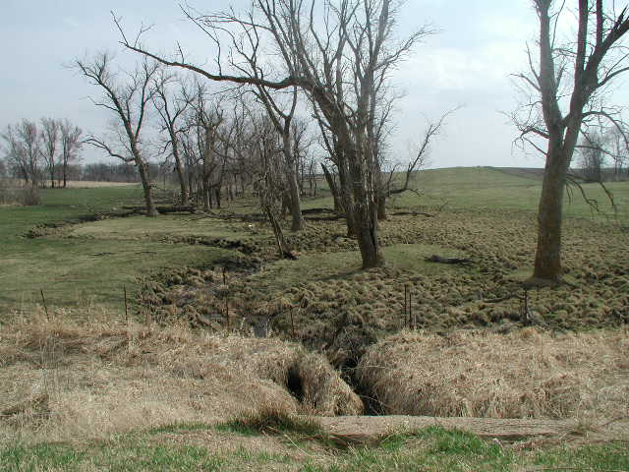
Figure 5 Landstein’s neighbor’s land: Here the farmer has removed all non-native trees and turned the land along the creek into a grazing area. This helps stop erosion and allows the farmer to use all available land.
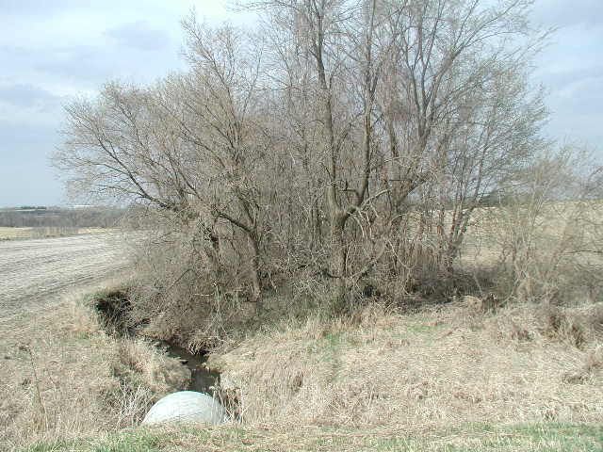
Figure 6 Landstein’s land: Dense growth of non-native trees along creek. This decreases the farmer’s land because of drainage problems and erosion.

The third site, referred to as Valley Grove, was about 100 to 200 feet south of 155 Street East and 200 feet east of Ibson Avenue. The tile was draining water from Valley Grove preserve, which is inactive farmland. It has been converted from farmland into a reserve over the past three years for the restoration land around the church and down to the border with the Scientific and Natural Area, and 5-8 years for the field above the tile line (where trees were planted) (Gary Wagenbach). The tile was surrounded with moderately dense forest. There was roughly 20 feet of forest between the edge of the old farmland and where the tile drained.
Observations:
The amount of water that passed through the tiles increased as the weeks went by, most likely because there was an increase in rainfall. The water that came out of the tiles was completely clear; more than we could even test using the 1.2-meter secchi tube. The water temperature of all the tiles increased throughout the weeks as well. The nitrate levels at the active farms were much higher than at Valley Grove, the non-active farm (see Figure 7). The chloride and sulfate levels at the Valley Grove farm were higher than at the active farms (see Figures 8 & 9).
Results:
The nitrate levels for Landstein and Cates were high, as much as 8.74mg/l for Landstein and 14.6mg/l for Cates (Figure 7). The nitrate level for the Valley Grove natural prairie was 1.29mg/l (Figure 7). Normal levels of nitrate in rainwater are .136mg/l (Table 1). According to data from the Mississippi River, the Nitrate levels are around 0.582mg/l (Cannon River group). The chloride and sulfate concentrations were similar for Landstein and Cates but Valley Grove had higher concentrations of both elements (Figure 8 & 9).

Table 1: Complete collected data from the past studies and our own.
____________________________________________________________________________
Date | Fluoride  (mg/L) | Chloride  (mg/L) | Nitrate  (mg/L) | Sulfate  (mg/L) | Conductivity  (μS) | Turbidity  (m) | Temp.  (˚C) | Dissolved Oxygen  (mg/L) | Salinity  (ppt)
Landstein
04/15/2003 | 0.1721 | 19.4704 | 17.4252 | 24.5846 | 380.7 | 1.2 | 3.2
04/22/2003 | 0.1694 | 17.2791 | 26.9293 | 24.8844 | 381.4 | 1.2 | 4.9 | 10.82 | 0.3
04/29/2003 | 0.1688 | 16.4919 | 25.1756 | 24.193
05/06/2003 | 0.1624 | 17.0242 | 27.2324 | 24.405 | 263.5 | 1.2 | 7.2 | 11.05 | 0.2
05/13/2003 |  |  |  |  | 377 | 1.2 | 8.5 | 10.29 | 0.3
Cates
07/17/2001 | 0.2585 | 14.5631 |  | 9.9123
07/19/2001 | 0.2765 | 13.9321 |  | 10.7932
07/23/2001 | 0.2544 | 12.6511 |  | 9.7544
04/15/2003 | 0.1596 | 16.3375 | 47.9356 | 14.207
04/22/2003 | 0.1518 | 14.4247 | 60.3626 | 11.5488 | 403 | 1.2 | 4.1 | 12.9 | 0.3
05/01/2003 | 0.1493 | 14.9142 | 60.4717 | 10.4602 | 686 | 1.2 | 5.9 | 13.91 | 0.3
05/06/2003 | 0.1563 | 15.1213 | 64.6848 | 10.4809 | 442 | 1.2 | 6.3 | 12.8 | 0.3
Valley Grove
07/16/2001 | 0.3162 | 26.773 | 0.464 | 25.992
04/22/2003 | 0.1851 | 1.9748 | 2.3451 | 9.8919 | 0 | 1.2 | 5 | 0.55 | 0
04/29/2003 | 0.176 | 2.0184 | 3.1486 | 9.6082
Rain Water
04/17/2003 | 0.2181 | 0.9161 | 0.6018 | 1.3335
_________________________________________________________________________________
Figure 7 Nitrate-N at Landstein, Cates and Valley Grove. This graph shows the increased Nitrate concentration in tile runoff for the active farmlands (Cates and Landstein). Therefore, farming techniques must increase the nitrate concentration since the unused land has relatively little nitrate in the tile runoff.

Figure 8 Chloride concentrations for all sites. This graph shows that Cates and Valley Grove have much higher concentrations of Chloride than Landstein. Since Valley Grove was the control tile and Cates had similar concentrations, we concluded that active farming has no effect on the Chloride concentration in tile runoff.
Figure 9 Sulfate Concentrations for All Sites. This graph shows the decreased concentrations of sulfate in the tile runoff from the two active farms (Cates and Landstein). Since the unused land had much higher concentrations, active farmland must lower the sulfate concentration in tile runoff.

Discussion:
Several of the agricultural departments in major universities have done research into tile drainage. For example, the University of Minnesota has ongoing research about the effects of different depths and spacing of tiles. There is no conclusive data yet, but data from 2001 and 2002 suggest that subsurface drains placed at shallower depths (e.g., 3 ft. instead of 4 ft.) can substantially reduce annual subsurface drainage volumes and nitrate losses. Computer simulation is being undertaken to extend these results to other soil types and longer climatic records (Sands, 2002). Missouri, Iowa, Ohio and Illinois State Universities, among others, have also done research into the effects of tile drainage. Also, according to a 2001 report from Ridgetown College and University of Guelph, various studies have reported elevated levels of nitrogen, pesticides and pathogens in tile drainage outflow from chemical additives and manure (Fraser, 2001). This is because the nitrogen and some pesticides are soluble in water and can be moved by the tiles. On the other hand, drainage tiles can also be good for the environment. According to the report, tile drainage can reduce soil erosion, phosphorus, potassium and pesticide losses from fields by as much as 40, 48, 29 and 35% respectively, due to both decreased surface runoff and increased infiltration. This is because the soil can filter contaminants as the water flows through, until they are taken up by plants or biodegraded by soil organisms. They are also a good way of decreasing soil erosion.
The National Soil Tilth Laboratory researched burying wood chips in trenches adjacent to the tile to act as additional carbon sources to increase the rate of de-nitrification (Jaynes, 2002). It is the only of the methods they tried that actually reduced the amount of nitrates in the water (see Figure 10). The main question with that method is how long the wood chips would be effective.
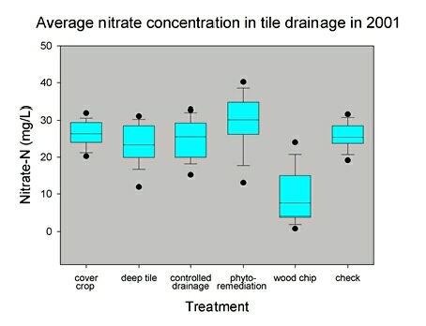
Figure 10 Average nitrate concentration in tile drainage in 2001 in Ames, Iowa from Jaynes, 2002
We conclude that the active farmlands are producing more nitrates than the prairie. The rainwater nitrate levels show that the nitrate levels in the water coming out of the active farmland tiles are well above normal (Figure 7). Does this have an effect on the streams and does it changes the chemistry of the streams? The Rice Creek data shows a range of nitrate concentrations from 11.5mg/l to 17.9mg/l. This is much higher than the normal rainwater concentration and therefore seems to be affected by the increase of nitrates from the tiles. This is also higher than the EPA maximum of nitrates in drinking water, which is 10 milligrams per liter (Clark, 1989). The Mississippi River data also shows a slight increase in nitrate levels above the normal rainwater concentration (Cannon River group). Thus, we attribute this increase in the nitrate of the Mississippi River from the tiles of the active farmlands.
The sulfate concentrations in the active farmland tiles were both low compared to the unused land. We assumed, from this data, that active farms decreased the amount of sulfate runoff. Because the chloride concentrations in the tiles did not seem to be affected by land usage, we concluded that active farms do not affect chloride concentrations.
We do not know what other factors could be contributing to the increased level of nitrate in the Mississippi. We did not account for other pollutants and micro bacterial processes. We also do not know how many farms have tiles. Although we know that nitrogen has a negative affect on the organisms in the streams, these affects are difficult to see. There is a Dead Zone in the mouth of the Mississippi where aquatic plants flourish due to the increased levels of nutrients, depleting the oxygen supply and making it impossible for larger organisms to survive. Even though our study takes place on a relatively small scale, our research suggests that farms have an impact on this Dead Zone, but to what extent we do not know.
We can conclude that tiles of active farms produce high nitrate levels, which have a negative impact on the environment. We can also generalize that the nutrients and fertilizers, added to farm soils to produce higher yields, have negative effects on the water quality of the region. The increase of nutrients on the farmland leads to an increase of nutrients and pollutants in the water. The increase of rainfall in the spring increases the amount of runoff from the tiles and the pollutants in the water. The data from Valley Grove suggests that when farming practices stop, the levels of nutrients and pollutants in the water decrease a significant amount.

Conclusion:
From the data, it can be concluded that tiles are a source of pollutants, significantly nitrates, in water supply of streams and lakes. Water from tiles on active farmland has more nitrates than inactive farmland or rainwater. As rain falls onto the farmland and travels through the soil, it dissolves a high amount of nitrates. It then flows into water supplies with high levels of nitrates. These nitrates have many negative effects, including eutrophication, which increases water filtration and treatment costs. Though the tiles have many benefits for the farmers, without data from runoff of farms without tiles or wetlands, it is indiscernible whether tiles are reducing or increasing the amount of pollutants compared to other farming practices. It would be recommended for future studies to test the water in wetlands, normal farm runoff, and tiles.

References:
Clark II, Edwin; Haverkamp, Jennifer A. and Chapman, William. 1985. Eroding Soils; The Off-Farm Impacts. The Conservation Foundation, Washington D. C. 36-44, 105-110.

Fraser, Heather and Ron Fleming. 2001. Tile Drainage – Questions and Answers. Ridgetown College, University of Guelph. http://www.ridgetownc.on.ca/research/rfleming/Reports/faqs123.pdf

Geneva Historical Society. Johnston Farm. http://www.genevahistoricalsociety.com/johnston.html

Jaynes, Don, et. al. 2002 Nitrate Contamination of Surface Water from Tile Drains. National Soil Tilth Laboratory. http://www.nstl.gov/research/onepage/1pkelly.html

Ribaudo, Marc. 2000. Agriculture Resources and Environmental Indicators: Water Quality Impacts of Agriculture. ERS Agricultural Resources and Environmental Indicators No. AH722. http://www.ers.usda.gov/publications/arei/arei2001/arei2_3/DBGen.html Chapter 2.3, 1-10.

Sands, Gary. 2002. Environmental and Agronomic Impacts of Subsurface Drainage Design.
University of Minnesota. http://www.bae.umn.edu/annrpt/2002/research/lwr4.html

Wagenbach, Gary. 2003. Professor of Biology at Carleton College.

Weaver, M. M. 1964. The History of Tile Drainage. Valley Offset Inc. Deposit, NY.

Acknowledgements:
Thanks to Liz Clark for giving the presentation on how to use GIS and for explaining the ion chromograph. Thanks also to the Geology department for the use of the instruments, and Bereket Haileab for providing advice and information and for doing the ion chromograph tests on our water samples.

